Lesson plan

Long-term plan unit: 7 Food and drink |  |  | School: Auliekol school gymnasium named after Sultan Baimagambetov
Date: 15.04-15.04 |  |  | Teacher name: Kozhagaiyeva G
Grade: 1 |  |  | Number present: |  | absent:
Theme of the lesson: Animals like …
Learning objectives(s) that this lesson is contributing to |  | 1.UE9 use common present simple forms [positive, negative and question] to give basic personal information  1.S5 use words in short exchanges  1.L3 recognise with support common names and names of places; recognise the spoken form of a limited range of everyday and classroom words  1.S1 make basic personal statements about people, objects and classroom routines
Lesson objectives |  | All learners will be able to:  - identify at least 3 words from the list of animals’ food vocabulary  - recognize all the words and match at least 3 of them  - name types of food and animals intelligibly  - make 2 sentences what animals like  Most learners will be able to:  - identify at least 6 words from the list of animals’ food vocabulary  - recognize all the words and match at least 6 of them  - make 5 sentences what animals like  Some learners will be able to:  - identify at least 10 words from the list of animals’ food vocabulary  - recognize all the words and match at least 10 of them  - make 7 and more sentences what animals like
Assessment criteria |  | Learners have met the learning objective (1..L3) if they can:  recognize and match 7-10 words of animals’ food
Value links |  | Respect, Cooperation
Cross curricular links |  | Science
ICT skills |  | Using videos
Previous learning |  | Food words
Plan
Time | Planned activities |  |  |  |  | Resources
Beginning | Organizational moment  Hello, boys and girls  How are you?  What day is it today?  What is the weather like today?  Warming up  Revision of the names of animals  - If you have plastic toys for the animals you can use them or you can use animal flashcards. Before the class put the toys or flashcards in a bag. Bring out the bag and peer in – make surprised noises to get the full attention of your students. Slowly, inch by inch, pull out the animals – chorus the animal name "e.g. What's this? It's a (lion). (Lion), (Lion), (Lion)". Then chorus the animal noise (E.g. "What noise does a lion make?" "Roar!").  - Pass one of the animals or animal flashcards to the nearest student. As you pass, say "(lion) (roar)". Have the students pass all the animals around the circle, all the while saying the animal name and noise.  NOTE: be sure to teach the plural for animals ("mouse" –> "mice").  Play "Flashcard touch" and "The missing flashcard" game  - Keep the flashcards on the floor. Tell your students to sit around the flashcards on the floor (or on a table) and to put their hands up in the air. Say a flashcard (e.g. "horse") and students have to quickly touch the correct card. Play a few rounds. After that, tell your students to close and to cover their eyes. Turn over one of the cards. Say, “Open your eyes”. The students have to shout out the missing card. |  |  |  |  | Flashcards  Toys
Middle | Demonstration  - Teacher presents, using visuals, vocabulary relating to different types of food animals eat  grass, fish, bananas, milk, leaves, birds, bugs etc.  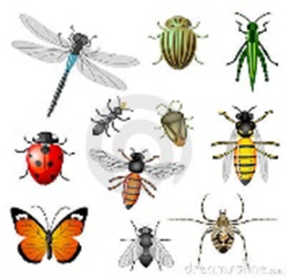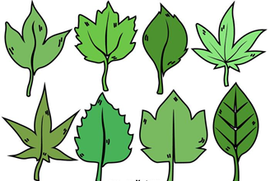  - Sit everyone in a circle, put on some music, and have everyone pass all of the flashcards around the circle (in the same direction). So the music will be playing and all of your flashcards will be going around the circle. Suddenly stop the music – the students holding the flashcard must shout out the name of the food they are holding. The last person to shout out the correct word is out (and also remove their flashcard). Keep playing, with each round the last person going out. This should end with just 2 students passing two flashcards back and forth.  Introduce "Monkeys like" and " Monkeys don't like"  - Leaners listen to the song  - Learners look at the board. The board is divided into two sections: "likes" on the left and "dislikes" on the right (indicated with a smiley and unhappy face).  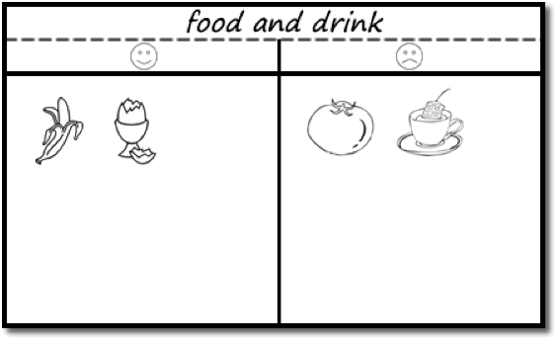  - First, put a food or drink flashcard in the 'like' column (such as a banana). Get everyone to shout out what you have put. Show the picture of monkeys. Gesture that they like this (say "Yummy!" and rub your tummy and smile – make it obvious that monkeys like it a lot). Say, “Monkeys like bananas".  - Next, put something in the 'dislike' column (such as bugs). Again, get everyone to shout out what you have put. Gesture that monkeys don't like this (say "Yuk!" or "It stinks!" and grimace – make it obvious that you don’t like it). Say, "Monkeys don’t like bugs".  Practice  Put the students into pairs. Each student has a picture of animals. They are going to make sentences using the food and drink items on the board. Model with a student first, so everyone understands what to do: Teacher says "bananas" – choosing an item from the board. The student has to make a sentence (e.g. "Monkeys like bananas"). Then in pairs, students take turns in choosing a food item for their partner to make a sentence about. For example:  Student A: Milk!  Student B: Cats like milk!  Student B: Grass!  Student A: Cats don’t like grass!  Encourage the use of phrases such as "Yummy", "Yuk».  Controlled Practice Listening  Students are given worksheets with pictures of food. They listen to the sentences and tick “Yes” or “No”  - Bears like eggs.  - Horses like fruit.  - Cows like grass.  - Tigers like fish.  - Chickens like meat.  - Zebras like milk.  - Giraffes like leaves  - Penguins like bugs  - Ducks like vegetables  - Frogs like water |  |  |  |  | PPT  Song  https://www.youtube.com/watch?v=7DYjfjaZGas  Flashcards  Worksheet
End | Feedback  Students share opinions if they liked/disliked the lesson by putting their thumbs up/down and explaining the reasons using simple language
Additional information
Differentiation – how do you plan to give more support? How do you plan to challenge the more able learners? |  | Assessment – how are you planning to check learners’ learning? |  | Health and safety check  ICT links
More support:  - These students may work with a stronger student to support them during the vocab activities.  More-able learners:  Encourage very strong students to model answers |  | Students will be assessed through the controlled practice activity |  | - Make sure power cords/outlets are not a tripping hazard  - Everyday classroom precautions
Reflection
Were the lesson objectives/learning objectives realistic? Did all learners achieve the LO?
If not, why?
Did my planned differentiation work well?
Did I stick to timings?
What changes did I make from my plan and why?
Summary evaluation
What two things went really well (consider both teaching and learning)?
1:

2:

What two things would have improved the lesson (consider both teaching and learning)?
1:

2:

What have I learned from this lesson about the class or achievements/difficulties of individuals that will inform my next lesson?

