Short term lesson plan
Unit of a long term plan: Unit 7  The natural environment |  |  |  |  | School: Massanchi school # 12
Date: |  |  |  |  | Teacher name: Chshimeyeva R.G.
CLASS: 2 |  |  |  |  | Number present: |  |  | absent:
Lesson title |  |  | What can animals do?
Learning objectives(s) that this lesson is contributing to (link to the Subject programme) |  |  | 2.UE13 use can to talk about ability and to make requests and offers; use can / can’t to talk about permission  2.S3 use a limited range of basic words, phrases and short sentences to describe objects, activities and classroom routines  2.L4 recognize with support short basic questions relating to features such as colour and number
Lesson objectives |  |  | All learners will be able to:  - Identify simple questions with support  - Recognize colour and number  - Tell about ability, make requests and offers, and ask for permission using can and can’t  Most learners will be able to:  - Talk about ability, make requests and offers, and ask for permission using can and can’t without support  Some learners will be able to:  - Apply a limited range of basic words, phrases and short sentences to explain rules, activities and classroom routines without mistakes
.Assessment criteria |  |  | - Respond to the questions  - Identify simple questions with support  - Recognize colour and number  - Talk about ability, make requests and offers, and ask for permission using can and can’t
Language objective |  |  | Can, can’t, climb, bark, sing, fly, swim, eat, jump, run, litter, feed, tease  Useful classroom language for dialogue/writing:  Discussion points:  What can animals do?  What can’t animals do?
ICT skills |  |  | Projector
Values links |  |  | Learners will work together as a group/ pair showing respect and being polite will each other respect to animals.
Mangilik Yel |  |  | National unity, peace and harmony in our society: Kazakh patriotism and civil responsibility, respect, cooperation, transparency
Intercultural awareness |  |  | Learners can speak about facilities of animals on different languages
Kazakh culture |  |  | Learners can speak about facilities of animals on Kazakh languages
Cross-curricular links |  |  | Biology, art, math
Previous learning |  |  | Learners already know about wild and domestic animals, colours, numbers. Divide animals to wild and domestic. Use modal verb can/can’t.
Pastoral care |  |  | Health is not valued till sickness comes.
Plan

Planned timings | Planned activities (replace the notes below with your planned activities) |  |  |  |  |  | Resources
Start  5 min | Teacher greets the class and explain lesson objectives  Warm-up: “Odd one out”  Stage objective- to engage and excite learners with the topic being introduced.  Assessment- Peer assessment  IP-T-SS  Teacher shows learners either a set of word or pictures (with a link to the lesson content). Learners should explain which one does not belong with the rest and give a reason why.  - Cat, dog, cow, lion, horse  - Lion, zebra, giraffe, bear, sheep  - Hen, goat, leopard, duck  - Frog, hare, wolf, mouse, elephant  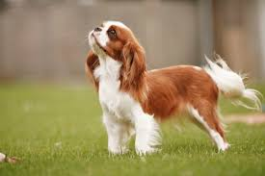    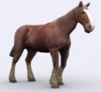    Answer the questions:  - What is your favorite animal?  - What colour is it?  - How many lags does animal has? |  |  |  |  |  | Flashcards
Middle  30 min | Presentation:  Pictionary  Stage objective- to activate learners’ knowledge on the theme.  Assessment- Peer assessment  IP-T-SS  Task 1  Teacher read the text about rules for visitors. Learners listen to the text and to depict rules.  Text  “ZOO RULES”  Be kind to the animals. Do not throw any objects at any animal.  Stay on the Marked Trails. Do not run. Do not cross over fences or barriers. All animals can be dangerous.  Respect the Garden. Do not deface or climb trees. Do not remove any plant material.  Descriptor: A learner  - Listens to the text attentively  - Use images to depict rules for other learners to guess  Dramatize  Stage objective- to activate learners’ knowledge on the theme.  Assessment-peer assessment  IP-T-SS  Task 2  Leaners image that they going to travel to the Zoo. Teacher asks learners to: “Clap hands, stomp feet, and say “let’s go’!” Learners watch a video about animals “Yes, I Can! | Animal Song for Children | Super Simple Songs” after that learners answer the convergent questions?  CONVERGENT QUESTION  Answer the questions: Yes, it can/No, it can’t  - Can a bird fly?  - Can a bird clap?  - Can an elephant fly?  - Can an elephant stomp?  - Can a fish swim?  - Can a fish stomp?  - Can a gorilla swim?  - Can a gorilla climb?  - Can a buffalo climb?  - Can a buffalo run?  Descriptor: A learner  - Claps hands, stomps feet, says “let’s go!”  - watch a video  - Answers the questions correctly.  Physical training: “If You are Happy | Super Simple Songs”  Differentiation  Peer conference  Stage objective- to check learners’ comprehension; to develop critical thinking skills.  Assessment- peer assessment  IP-SS-SS-T  Learners divide into 3 groups  Task 3  Group “A”  Learners complete the table: put a tick (v) if animal can do, and cross (x) if animal can’t do. Say what animal can or can’t do.  Jump Bark Climb Sing Swim Eat Run Fly  bird v x  elephant  fish  gorilla  buffalo  Group “B”  Learners make a scheme of the Zoo and say what animals are there?  Group “C”  Learners write rules for visitors and explain what they can/can’t do at the Zoo. (without mistakes)  Descriptor: A learner of:  - Group “A” completes the table and says what animals can/can’t do.  - Group “B” makes a scheme of the Zoo and says what animals are there? (without support)  - Group “C” writes rules for visitors and explains what they can/ can’t do at the Zoo. (without mistakes)  Task 4  Work with picture  Stage objective- to improve learning  Assessment – teacher’s oral assessment  IP- SS-T  Look at the pictures and describe them. Use can/can’t to talk about ability, permission and requests.      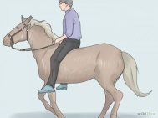  Example: I can ride a horse.      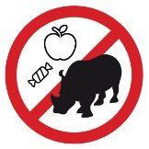  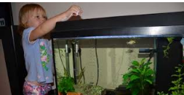    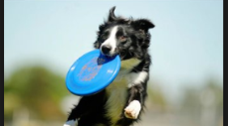  Descriptor A learner  • names animals properly;  • uses topic related vocabulary;  • Uses can and cannot to express ability, permission, offers and requests. |  |  |  |  |  | Text “Zoo rules”  https://www.youtube.com/watch?v=_Ir0Mc6Qilo  https://www.youtube.com/watch?v=l4WNrvVjiTw  Posters and markers  Pictures
End  5 min | Feedback  ”Draw your brain”  Stage objective- to highlight how learners learn.  Assessment- self assessment  IP- SS-T  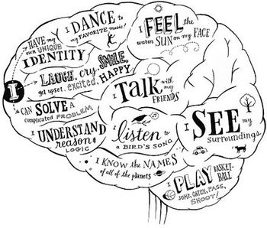  Learners draw the outline of a brain in their exercise book and fill it with words that explain what they have learnt during that lesson  .  Descriptor: A learner  - Draws a brain in exercise book  - Fills it with words that explain what learner has learnt during the lesson
Additional information
Differentiation – how do you plan to give more support? How do you plan to challenge the more able learners? |  |  |  | Assessment – how are you planning to check learners’ learning? |  | Health and safety check
Differentiation by type of task:  For all learners task with support.  For more learners task in which they must did it without support  For some learners task without support and they must did without mistakes |  |  |  | Task 1 –peer assessment  Task 2 – peer assessment  Task 3 – peer assessment  Task 4 – formative assessment  Feedback – self -assessment |  | Use physical training during lesson through listening and dancing while watching video  “If you are Happy | Super Simple Songs”
Reflection  Were the lesson objectives/learning objectives realistic?  Did all the learners achieve the lesson objectives/ learning objectives? If not, why?  Did my planned differentiation work well?  Did I stick to timings?  What changes did I make from my plan and why? |  | Use the space below to reflect on your lesson. Answer the most relevant questions from the box on the left about your lesson.  Lesson objective is realistic because all examples are followed from real life and all tasks achievable. Differentiation work was well, but I must to improve to give the instruction and correct to dose time.  After feedback with the trainer and colleagues has helped me to realize all my mistakes and improve work with learners in development of the short term plan.
Summary evaluation

What two things went really well (consider both teaching and learning)?

1: Setting up the theme of the lesson

2: Warm up activity

What two things would have improved the lesson (consider both teaching and learning)?

1: To give instructions for the tasks

2: To dose time

What have I learned from this lesson about the class or individuals that will inform my next lesson?

