The Pedagogical College after Zh.Dosmukhamedov

Demonstration lesson
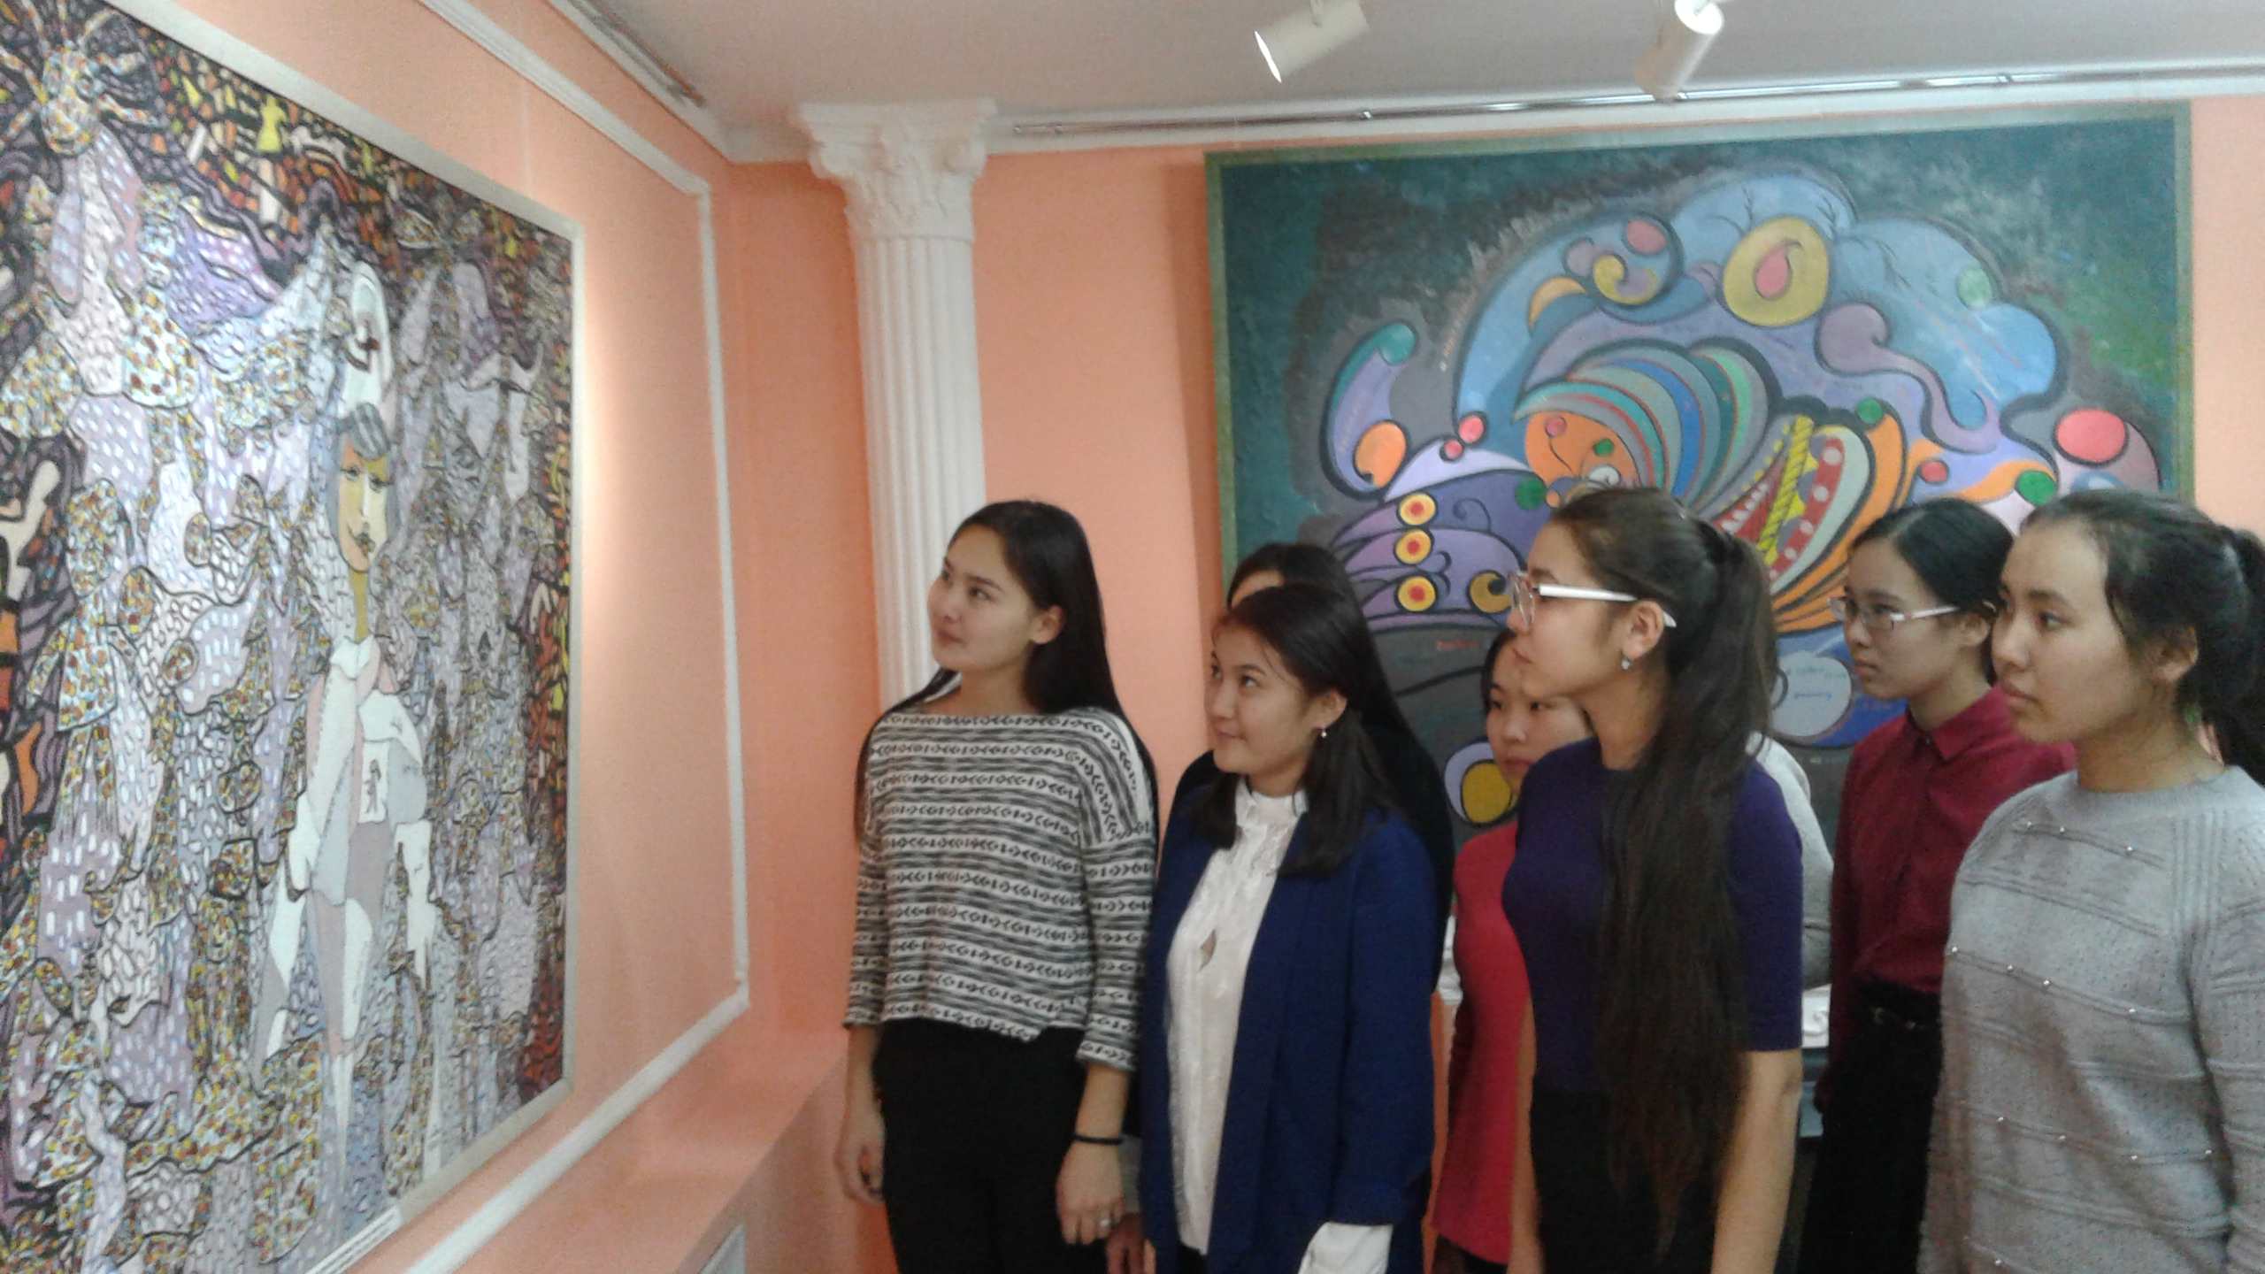

Arts and Entertainment

Teacher:Sh.E.Mukhtarova

Uralsk 2017

Пәні: | Тереңдетілген шетел тілі
Топ: | 2а КДО-9
Уақыты:
Сабақтың тақырыбы: | “Arts and Entertainment”
Құзыреттілікке жеткізетін сабақтың мақсат-міндеттері:  А) ақпараттық құзыреттілік  Ә) коммуникативтік құзыреттілік  Б) проблеманы шешу құзыреттілігі | “Arts and Entertainment” тақырыбы бойынша жаңа сөз тіркестерін,мәтінді, диалогты меңгерту  “Arts and Entertainment” тақырыбының лексикалық, грамматикалық материалы негізінде монологтық , диалогтық сөйлеу,ауызша және жазбаша қарым-қатынас жасау дағдысын қалыптастыру  “Arts and Entertainment” тақырыптары бойынша топтық, жұптық , шығармашылық жаттығулар орындай отырып оқуға, жазуға,сөйлеуге дағдыландыру
Сабақтың типі: | Аралас сабақ
Сабақтың әдісі: | Практикалық, сөздік, білімді бақылау, репродуктивтік
Сабақта қолданылатын педагогикалық технологиялар: | АКТ, сыни тұрғыдан ойлау
Пәнаралық байланыс: | Практикалық грамматика, қазақ тілі, орыс тілі,бейнелеу өнері
Оқыту құралдары: | “EDOsoft” бағдарламасының үлестірмелі материалдары, кестелер, компьютер,тақта,суреттер

Сабақтың барысы: | Оқытушының қызметі | Оқушының қызметі | Күтілетін нәтиже
EXPANDING ON  1. Ұйымдастыру бөлімі  Organizational moment  2.Үй тапсырмасын тексеру.  Checking homework in pairs Workbook:Page33,34 | Teacher: Good afternoon! I’m glad to see you.Today we are having an unusual lesson. We’ll deal with grammar in practice and talk about “Arts and Entertainment” Intermediate 1, Unit 5  Our task is to review grammar and to do lexical and grammar exercises, speak about “Arts and Entertainment” . Now look at the blackboard and write the date and day.  Let’s check your homework.  А.Mark the correct column: True, False or Not in Text Use the Explore text on page 70 to help you.  1. The name of the group that is being interviewed is “The Institute of Music”. T  2. The group plays jazz. F  3. Barry Jameson teaches at State University. T  4. All the members of the group are married. Not in the text  5. The group’s new song is called “Don’t Test Me”. F  6. The group’s first concert at State University was held a week before the radio interview. T  7. The group plans to give another concert at State University. Not in the text  В. Did you understand all the words in the Listening section? Match the words in A to their  definitions in B.  1. a graduate a . a short rest  2. a hit b. a large building used for concerts  3. a lecture c. someone who has completed a  university degree  4. the lead d. a long talk on a particular  subject  5. a break e. something that is very successful  or popular  6. an auditorium f. the main person in a band or  group | Оқушылар сабаққа әзірленеді, зейінін аударады  А.Mark the correct column: True, False or Not in Text Use the Explore text on page 70 to help you.  1. The name of the group that is being interviewed is “The Institute of Music”.  2. The group plays jazz.  3. Barry Jameson teaches at State University.  4. All the members of the group are married.  5. The group’s new song is called “Don’t Test Me”.  6. The group’s first concert at State University was held a week before the radio interview.  7. The group plans to give another concert at State University.  В. Did you understand all the words in the Listening section? Match the words in A to their  definitions in B.  1. a graduate a . a short rest  2. a hit b. a large building used for concerts  3. a lecture c. someone who has completed a  university degree  4. the lead d. a long talk on a particular  subject  5. a break e. something that is very successful  or popular  6. an auditorium f. the main person in a band or  group | Мұғалім мен оқушы арасында ынтымақтастық қарым- қатынас орнайды.  Үй тапсырмасына жауап береді  Тыңдау бөлімінде алған білімін бекітеді  Өз бетімен орындалған жұмыстың нәтижесін талдайды
3. Өткен материалды қайталау арқылы жаңа материалды қабылдауға дайындық  Workbook pages 33-34  Workbook pages 39 | Teacher: Now let’s pass to the next part of our lesson.Let’s play “Question Order“game.  Please divide into pairs . So let’s begin.  “Question Order “ Game  Divide into groups of four and arrange the words in the correct ordеr and form a question.The first group to complete all the sentences wins.  1. Was the actress Mary Reed presented  with a Golden Globe award for life-long  achievement last week?  2. Was pop star Mick Starlight, who is recovering in  hospital, sent cards and flowers by his fans?  3. Were dancers Sarah Hill and Anthony Elliot paid  $100,000 to appear in a special ballet  performance in Paris last week? | 1. Was the actress Mary Reed presented  with a Golden Globe award for life-long  achievement last week?  2. Was pop star Mick Starlight, who is recovering in  hospital, sent cards and flowers by his fans?  3. Were dancers Sarah Hill and Anthony Elliot paid  $100,000 to appear in a special ballet  performance in Paris last week? 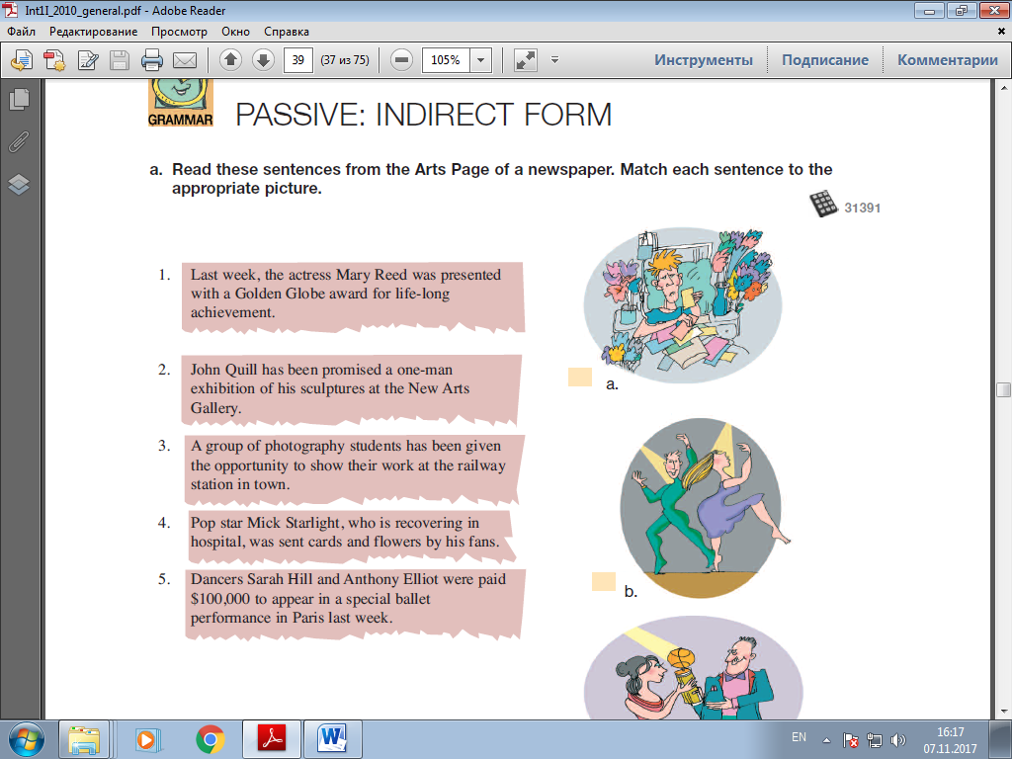 | Present Simple Passive  грамматикалық тақырыпты тыңдай отырып  қайталайды, ойын арқылы сұраулы түрді бекітеді,сөйлемдерді суреттермен сәйкестендіреді
LEADING INTO  Brainstorming.  4. Жаңа білімді меңгерту.  1.Introducing the topic of the Reading section  2.Brainstorming vocabulary of Reading section  3.Introducing the content of the Reading section.Workbook Explore Texts Page 70-71  4.”Vincent van Gogh”  Handout 26  2.Practicing the language of inviting  Watching video.  5. Жаңа білімді бекіту.  1. Article in the magazine “Mona Lisa’s Mystery”  2.Singing a Song  ” We Love Colours”  3. The Grammar Section. Introducing the Passive Voice-Indirect Form.  4.Using verbs that can have two objects.  ASSIGNING  6.Компьютерлік бөлім.  Introducing the content of the  7.Үйге тапсырма  8.Қорытынды  Reflection of the lesson. | Teacher: Now look at the blackboard and write the topic on them.“Arts and Entertainment” .The question is “What is your favourite picture?”  1.How would you define art?  2.Should an artist be freeto use whatever materials he likes,even garbage?  3.Do you like modern art?Why?Why not?  4.What is Entertainment?  Arts  Entertainment  Student A  You have the first half of a text about the artist Vincent van Gogh. Read your half of the text and ask your partner the following  questions about van Gogh’s later life.  1. What influenced his work?  2. What was his artistic ideal?  3. Where did he paint most of his major works?  4. Was his work popular during his lifetime?  5. One other interesting fact  Now your partner wants to find out about van Gogh’s early life. Be prepared to answer  her questions.  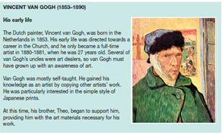  Student B  You have the second half of a text about the artist Vincent van Gogh. Your partner has the  first half of this text. Read your half of the text and ask your partner the following questions  about van Gogh’s early life.  1. Where was he born?  2. When did he become an artist?  3. How did he study art?  4. Who supported him financially at the start of his career?  5. One other interesting fact  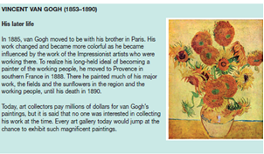  1.How about coming with me to the Gumarov Museum?  2.How about going to the...?  3.How about meeting me for tea tomorrow.  1.Sorry I can’t.  2.I’d like to but….,  3.I’m afraid it’s not possible.  4.Oh dear,I won’t be able to.  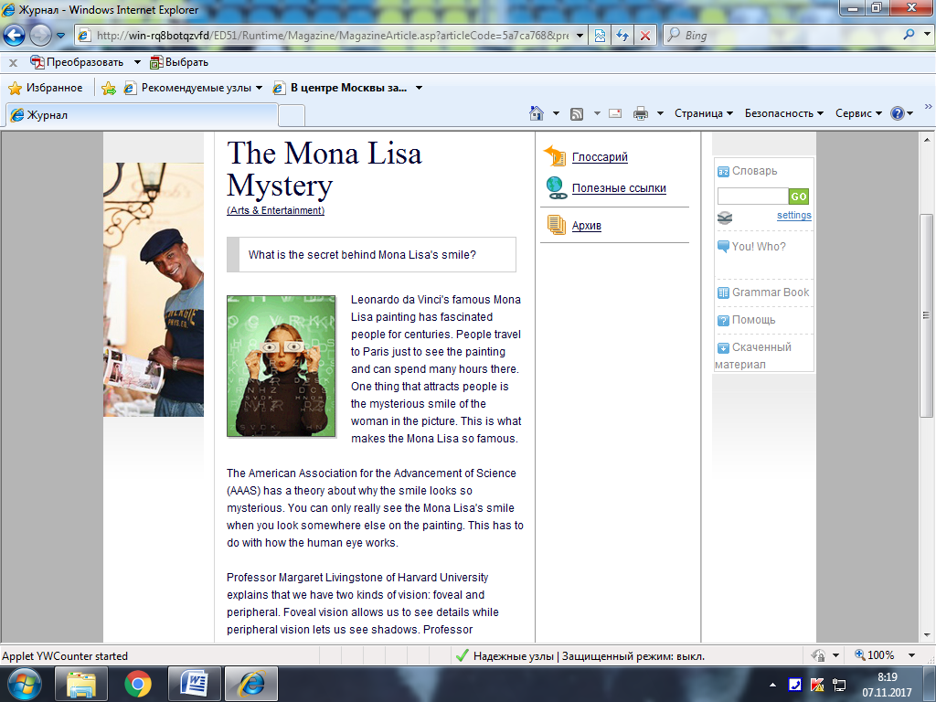  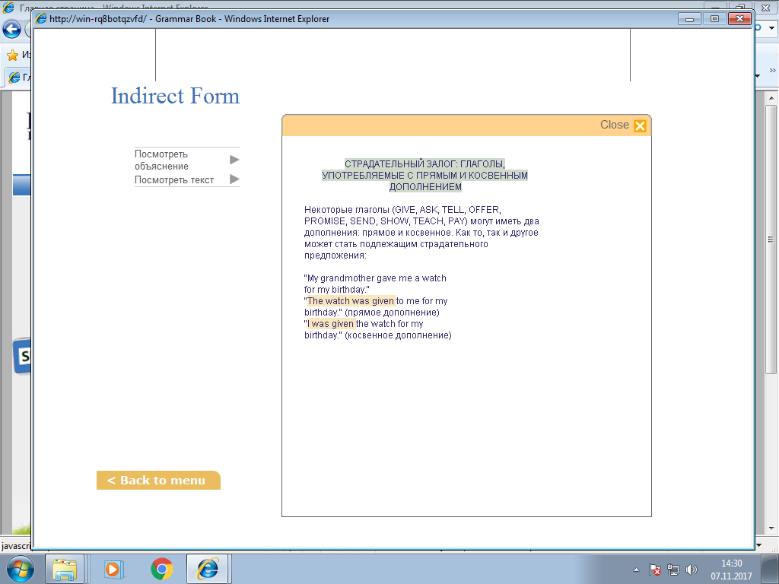  We use the Passive Voice when the person performing the action is unknown.  e.g. I was told the news.  The verbs offer,promise,ask,tell,pay,give  ,send,award,teach, show can have two objects,one direct one indirect.Both of these objects can be used in the Passive Construction.  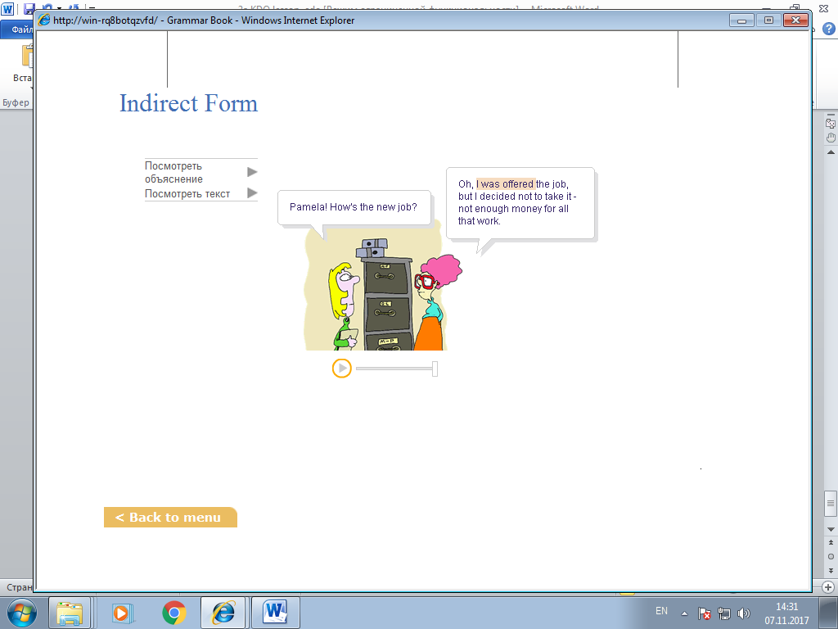  Passive Voice: Indirect Form  - Pamela! How's the new job?  - Oh, I was offered the job, but I decided not to take it - not enough money for all that work.  Teacher: Let’s conclude our lesson.  Teacher: Let’s turn to computer lessons  Computer Path:My courses-Intermediate 1-Arts and Entertainments- Reading-Speaking-Grammar Sections  Explain/ Demonstrate workbook activities –page 35-40  Сабаққа белсенді қатысқан оқушылар бағаланады. Баға түсіндіріледі. | Art is a diverse range of human activities.Art is painting.Art is singing and dancing. Art is playing musical instruments.  Entertainments are the human activities for pleasure and leasure.  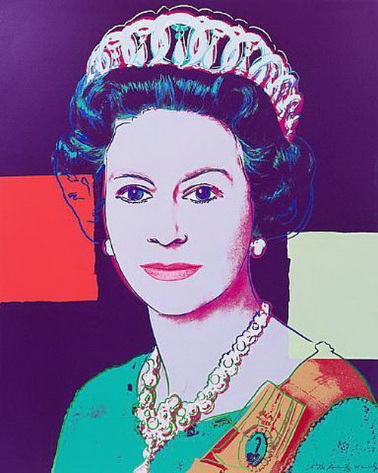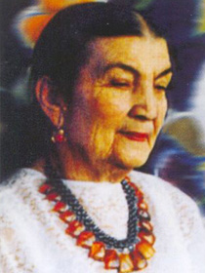  Student A  1.His work changed and became more colorful as he became influenced by the work of the Impressionist artists who were working there.  2.His long-held ideal was becoming a  painter of the working people,  3. He painted much of his major works in Provence,  southern France.  4. His work wasn’t popular during his lifetime.  5.Today, art collectors pay millions of dollars for van Gogh’s paintings.  1.Vincent van Gogh, was born in the  Netherlands in 1853.  2.He only became a full-time  artist in 1880-1881, when he was 27 years old.  3.Van Gogh was mostly self-taught.  4.At this time, his brother, Theo, began to support him, providing him with the art materials necessary for his work.  5.He was particularly interested in the simple style of  Japanese prints.  Mark which of the following phrases can be used for inviting or refusing an  invitation.  Inviting Refusing  1. How about going to an art exhibition?  2. Perhaps we could make it another time.  3. Can you come to the ballet tomorrow?  4. Sorry. I can’t.  5. Are you free for a movie?  6. I’m afraid it’s not possible.  7. Would you like to see a play?  8. Oh, dear. I won’t be able to.      Group1.True-False  1. Leonado da Vinci’ famous “Mother and child” painting has fascinated people for centuries - F  2. People travel to London just to see the painting and сan spend many hours there - F  3. One thing that attracts people is the mysterious smile of the man in the picture - F  4. This is what makes the Mona Lisa famous - T  Group2. Fill in the gaps:  - The … Association for the Advancement of Science (AAAS) has … about why the … looks so …  - You can only really … the Mona Lisa’s … when you look … else on the …  - This has to … with how the … … works.  - Professor Margaret Livingstone of … University explains that we have two … of vision: foveal and …  Group3. Match the words:  - 240-megapixel A. colors became a darker  - so old B. not changed  - cleaned up C. scanner and camera  - her ability D. Mona Lisa’s smile    WHITE - Mona Lisa, Leonardo da Vinci,Paris,foveal,peripheral visions,smile  RED - admiration,joy,happiness  YELLOW - trip to Paris,visit Louvre  BLACK - no secret, it’s only way of attracting people  GREEN- we’re to learn more about arts  BLUE- we’re to use masterpiece’s in our lessons  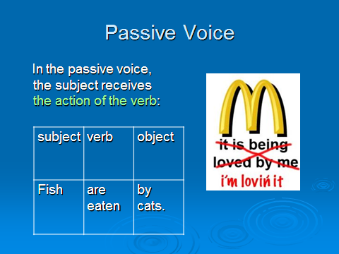  1.That vase was given me by my grandfather.  2.He was asked a question by the old lady.  3.They were told the answer by the teacher.  4.She was offered her first exhibition when she was only twenty.  5.The child was promised a present if he behaved himself.  6.The boy was sent a package by his parents.  7.I was shown around the city by my friends.  8.I was taught Spanish by an Argentinean woman.  9.They were paid a lot of money for their work.  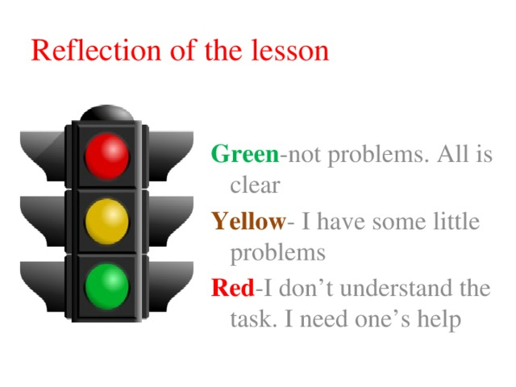 | Оқушылар білімін кеңейтеді,жаңа материалды қабылдайды.  Тақырып бойынша ой қозғау сұрақтарына жауап береді.  Венн диаграммасын толтырады, сөздерге анықтама береді  Жаңа мәтінмен жұмыс жасайды,оқиды,  жаттығуларын жұппен орындайды  Сұрақтарға жауап береді.  Сөйлемнің түрлерін анықтайды.  Рольдік ойын ойнайды.  Берілген сұрақтарға жауап береді.  Бір-бірін бағалайды.  Мәтінмен жұмыс жасайды,оны жазбаша,ауызша сөйлеуде қолданады .  «True-False»,«Fill in the gaps»,  «Match the words» жаттығуларын орындайды  «Диагональдап оқу» әдісін қолданып мәтінді оқиды  Топтық жұмыс орындайды, нәтижесін тексереді, бір-бірін бағалайды.  «Алты ойлау қалпағы» стратегиясын қолданып сөйлейді  Ырықсыз етісте екі толықтауыш қолданатын етістіктер енгізіледі.  Сөйлемдер құрастырылады.  «Ыстық орындық»  стратегиясын қолданып Passive-Voice.Indirect Form қайталайды.  Берілген тапсырманы компьютерде орындайды.  Сабақ қорытындыланады.

