Short- term plan

Unit 3: My family and friends  Lesson theme: Family and friends: She is…/ He is …/You are…/I’m… |  |  | School: Akzhar District  KGU Leningradskaya secondary school № 1
Date: |  |  | Teacher name: Tkachenko Oksana Gennadevna
Class: 1 |  |  | Number present: |  | Absent:
Learning objectives: |  | 1.L3 recognize with support common names and names of places; recognize the spoken form of a limited range of everyday and classroom words  1.S2 ask questions in basic exchanges about people, objects and classroom routines  UE7 use personal subject and object pronouns to give basic personal information
Lesson objectives : |  | All learners will be able to:
 |  | Recognize with support and name the words concerning the topic “My family”; the spoken form of everyday and classroom words
 |  | Most learners will be able to:
 |  | Аsk questions in basic exchanges about family
 |  | Some learners will be able to:
 |  | Give basic personal information about people and correct wrong information.
Language objectives: |  | Learners can:  Describe a person or a thing using personal subject and object pronouns and give basic personal information
 |  | Key words and phrases:
 |  | This is my family/She is…/ He is …/You are…/I’m…
Useful classroom language for dialogue/writing:
What is your name? My name is?
This is my father. He is big. She is my mother. She is nice. Thank you. Please.
Value links |  | Communicative abilities
Cross-curricular links |  | Art, music
Previous learning |  | Adjectives
Plan
Planned timings | Planned activities (replace the notes below with your planned activities) |  |  | Resources
Beginning  7 min | Teacher and pupils greet each other  Warming up “Hello Dolly”  Instruction  - Stand in pairs  - Repeat after me  What is your name? My name is.....  How are you? I am fine, thank you  (display questons)  - One by one take puppets from the box and greet each other and ask questions.  (Differentiation by teacher’s support) |  |  | Hello song  https://www.youtube.  com/watch?v=  x23rTDl4AMs
Middle  7 min  2 min  4 min  12 min | Task 1: Formative assessment  Learning objectives 1.UE7 use personal subject and object pronouns to give basic personal information  Level of thinking skills Application Comprehension  Assessment criteria 1.Can make statements using personal subject and object pronouns to give basic personal information 2. Correct wrong statements about people and things  Task  - Stand in a circle.  - Make true or false statements about your classmate on the left. One by one.  - Correct wrong statements.  Teacher’s note: Teacher starts to make statements about the first learner. For making statement -1 jetton. When a learner corrects wrong statement he gets one more jetton.  Assessment criteria Descriptor  1. Can make statements using personal subject and object to give basic personal information. 2. Use personal subject and object pronouns and correct wrong statements about people and things A learner 1. Makes basic statements about people using personal subject and object 2. Corrects wrong statements about people and things  (Differentiation by length of response )  Teacher’s oral feedback  Task 2 “This is my family”  Watching video “My family”  Lesson objectives introduction  What is the video about?  What can you see?  (Display question)  Look at the photo of the family  What can you see on this picture?  (Display question)  Listen to the teacher  Instruction  Stand up.  Come to my table.  Have figures of mummy, daddy, sister, brother and you .  Sit down.  Trace them on a piece of paper.  Colour them.  Show your picture to your neighbor.  Describe the picture of your family to your neighbor.  Show and say about your family to the whole class.  Note: While drawing teacher asks and listens to every child about his/her family.  Who is he? Who is she? Who is this?  (referential questions)  This is my family/She is…/ He is …/ I’m…  After creating a picture and describing it to a neighbor teacher asks students to take a badge from Magic box. If students take badges with a book they are to show and describe the pictures to the whole class.  (Differentiation by outcomes )  (Differentiation by scaffolding-pause-ask q-ns-pause-review)  Oral feedback  Reflection  Students go back to the lesson objectives and identify what they did well as well as what needs improvement. (with teacher’s support). |  |  | jettons    Interractive board https://www.youtube.  com/watch?v=  GiRUF7hvWuM  PP    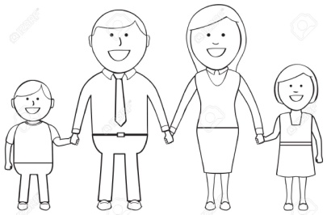  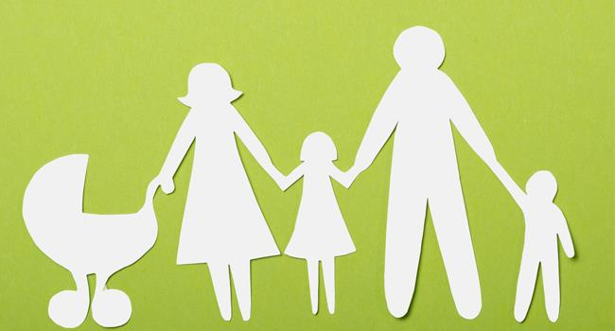  INSTRUCTION  1.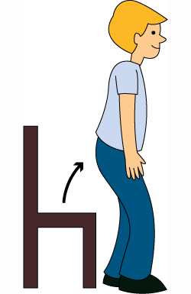 2. 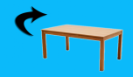  3.  4.   5.  6. 
End  3 min | Present your pictures to the class.

Additional information
Differentiation – how do you plan to give more support? How do you plan to challenge the more able learners? |  | Assessment – how are you planning to check learners’ learning? | Cross-curricular links  Health and safety check  ICT links  Values links
• Differentiation by teacher’s support  • Differentiation by length of response  •Differentiation by outcomes )  • (Differentiation by scaffolding-pause-ask q-ns-pause-review) |  | • Teacher’s oral feedback  • Formative assessment | • Art, music  •Work with the smart board not more than 10 min. Use water based markers.  •Video and PP(photo)  • Communicative abilities
Reflection  Were the lesson objectives/learning objectives realistic?  What did the learners learn today?  What was the learning atmosphere like?  Did my planned differentiation work well?  Did I stick to timings? What changes did I make from my plan and why? | Use the space below to reflect on your lesson. Answer the most relevant questions from the box on the left about your lesson.

3 My family and friends | Talking about different members of the family and friends; saying the days of the week | "Who is this?", "How are you?", "I’m fine thank you", "See you soon"; “What day is it today?”  I’m… You are… She is.... He is… and  Yes that’s right / No....  This is my mum. Her name is ...  His name is.. | father, mother, brother, sister, grandfather, grandmother, family, Monday, Tuesday, Wednesday, Thursday, Friday, Saturday, Sunday.  mum, dad, granny, granddad

