LESSON: Unit : Plants |  |  |  | School: Ledenervo school
Date: |  |  |  | Teacher name: S. Zhukenova
CLASS: 5 |  |  |  | Number present: | absent:
Learning objectives(s) that this lesson is contributing to |  | 5.S1 provide basic information about themselves and others at sentence level on an increasing range of general topics  5.S6 communicate meaning clearly at sentence level during, pair, group and whole class exchanges  5.R1 understand the main points in a limited range of short simple texts on general and curricular topics  5.W2 write with support a sequence of short sentences in a paragraph on a limited range of familiar general topics
Lesson  objectives |  | All learners will be able to:
- listen and repeat the words according to the topic “Plants”
- Use the words in the sentences according to the topic “Plants”
- Make up 2 sentences about plants with support
 |  | Most learners will be able to:
- Name and use the vocabulary of plants
- Complete the sentences about plants according to the text
- Make more than 4 sentences correctly about Plants
 |  | Some learners will be able to:
- Describe plants
- Answer the questions related to the new topic
- Make more than 6 sentences about plants without support
Previous learning |  | Weather and climate
Plan
Planned timings | Planned activities (replace the notes below with your planned activities) |  |  |  |  | Resources
Beginning  5 min | Warm up  - Song for children “Good morning”  - T. show PPT with video and s-s should listen and repeat the song |  |  |  |  | PPT 1
Middle  2 min  5 min  3 min  12 min  10 min  3 min | Introduсe  - T. shows PPT with pictures of flowers and asks “What is the theme of our lesson how do you think?  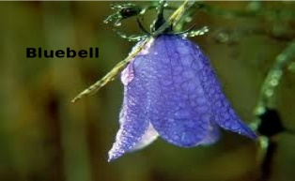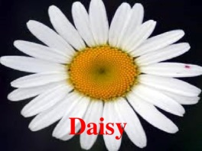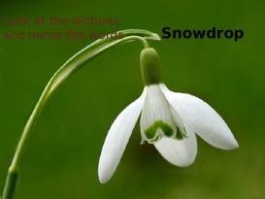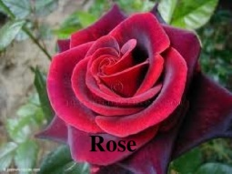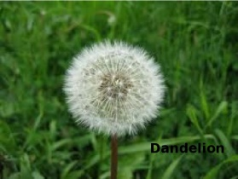  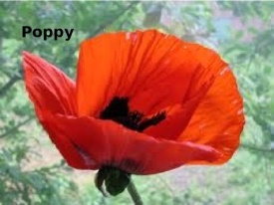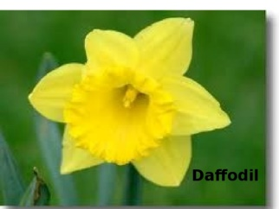  - And introduce with new words: snowdrop, poppy, daisy, dandelion, rose, daffodil, bluebell T. should say a word and Ss should repeat after.  Speaking  - T. At first you should answer some questions. You should answer yourself and ask somebody else.  - 1. Do you plant flowers?  - 2. When do you usually plant flowers?  - 3.What is your favourite flower?  Reading  Pre-reading T: Look at the words and say what about our text?  While reading: read the text  Post reading: Complete the sentences.  - The floral symbol of Great Britain is ____.  - The war between Lancastrians and Yorkists was in___.  - The House of Lancaster was decorated______.  - _____won the war.  Writing practice  T: Now you should divide into 3 groups and choose one flower and describe it using following questions (not less 6 sentences for stronger s-s and 2-4 sentences for less able s-s):  -What colour is it?  -Where does it grow?  -When?  -What does it look like?  Teacher supports less able s-s with word card.  (Peer assessment) |  |  |  |  | PPT 2  PPT 3  PPT 4  PPT 5  Wordsheet
End  5 min | Plenary  Ship  Attach to the ship the appropriate flag. If the lesson was good attach red flag, if didn’t really like green flag, if didn’t like at all black flag.
Additional information
Differentiation – how do you plan to give more support? How do you plan to challenge the more able learners? |  |  | Assessment – how are you planning to check learners’ learning? |  | Cross-curricular links  Health and safety check  ICT links  Values links
- Less able students can read and write difficult words from the text with support  - After reading the text some s-s can make sentences with help  - Stronger Ss can do independent work on definite tasks without support |  |  | - Through their answers to the questions after reading the text  - Through observation their group work after reading the text  - Through mutual evaluation presentation poster |  | - Learners will be safely arranged and seated in front of the monitor away from electrical outlets and cables.  - Whiteboard is used no more than 15-20 minutes  - Ss learn how to take care of animals.  - Ss will value natural resources and appreciate their motherland.

