LESSON: Climate and weather |  |  | School: school № 18 Zhanauzen
DATE: |  |  | Teacher name: Khozhametova Mekhriban
Class: grade 5 |  |  | Present:12 | Absent:0
Learning objectives | 5.S6 communicate meaning clearly at sentence level during pair, group and whole class exchanges  5.L1 understand a sequence of supported classroom instructions  5.W6 link, with some support, sentences into coherent paragraphs using basic connectors on a limited range of familiar general topics
Level of thinking skills | Higher order of thinking levels
Assessment Criteria | - Apply topical vocabulary to communicate clearly at sentence level during group and whole class exchanges  - Choose the right one from pictures by listening  - Write and report with support, about weather forecast using basic connectors
Lesson objectives | All learners will be able to:  - Apply topical vocabulary to talk about the weather  - Spell the new words with minor mistakes  Most learners will be able to:  - Listen and identify the weather by listening  Some learners will be able to:  - Write with some support sentences using basic connectors about weather of their regions.
Language objectives | Key words: weather, clear, sunny, cloudy, hailing, perfect, windy, rainy, snowy, foggy, hot, cold and stormy.  Useful classroom language/dialogue  How is the weather like?/ how is the weather gonna be?
Cross curricular links | Geography, The Kazakh Language
Values links | respect, cooperation
Previous learning  5min | Cities and countries. Venn diagram. Compare cities and countries
Plan
Planned things |  | Planned activities |  |  | Resources
Start  12 min |  | - Organizing moment.  Greetings  Dialogue with the duty  Divide the students into 4 groups by the direction of compass.  Group I-east  Group II-west  Group III- north  Group IV-south  - Checking homework.  - Brainstorming.    Solve the rebus puzzle and get the word “Weather”  W+ +her  Cluster. Connect the words you know about the weather. (GW)  weather  wind  rain  snow  - Presenting topical vocabulary with illustrated pictures.  Clear, sunny, cloudy, hailing, rainy, windy, snowy, foggy, hot, cold, stormy |  |  | Pictures of compass with colored parts of direction.  Flipcharts  PPT
Middle  8 min |  | - Writing. (IW)  Worksheet 1. Fill in the missing letter.  __unny.  Worksheet 2. Write the words to the pictures  Worksheet 3. Solve the crossword. |  |  | Worksheet 1,2,3  http://www.mes-english.com/worksheets/flashcards/weather_spelling.php
Descriptor |  | - Spell the words correctly
assessment |  | Formative assessment: pupils get emotional smileys. |  |  | Colored cards
  0-2mistakes | 3-4mistakes | 5or more
   |  | 
7 min |  | - Listening.  (W) Listen and identify. Choose one out of three. |  |  | Worksheet 4  http://www.123listening.com/files/weather_ccp3.php
Descriptor |  | - Listen and choose the right variant |  |  | Smileys
assessment |  | Formative assessment: pupils get emotional smileys.
  0-2mistakes | 3-4mistakes | 5or more
 |  | - Reading and speaking.  Go to link: www.m.accuweather.com  and look at tomorrow’s weather forecast of different parts of Kazakhstan and make a poster. Present it to the class..  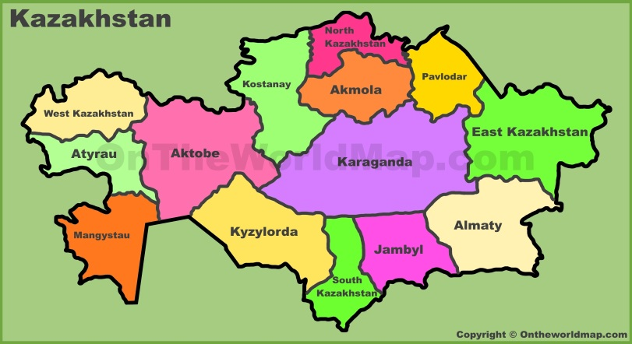  Group East: Find out tomorrow’s weather forecast for The east part of our country.  Group West: For the west part of our country  Group South: The south part of our country  Group North: The north part of our country. |  |  | Posters with administrative map of Kazakhstan and pictures of different weather.  www.m.accuweather.com
Descriptor |  | - Find information and speak clearly about tomorrow’s weather
Assessment |  | Formative assessment: pupils get emotional smileys. |  |  | smileys
  0-2mistakes | 3-4mistakes | 5or more
End  8 min |  | Feedback: Complete the Concept map  Homework: Write about tomorrow’s weather of Zhanauzen |  |  | Concept map
   | Temp | wind | Sun/rain/snow
  East KZ
  West KZ
  South KZ
  North KZ
Additional Information
Differentiation-how do plan to give more support? How do you plan to challenge the more able learners? |  | Assessment-how are you planning to check learners learning? |  |  | Health and safety check
Worksheet sort  Most support:  Use both images and words with missing letters  Some support:  Use only pictures  Minimal support:  Use crossword worksheet |  | Peer and self-assessment |  |  | Friendly atmosphere in class. Health saving technologies use games and physical exercises.
  Name:  Class: |  |  | 
  I can spell the
  words correctly
  I can listen and
  understand how
  is the weather
  I can speak about
  The weather of
  my region
  Total:
Reflection  Where the lesson objectives/learning objectives realistic?  Did all the learners achieve lesson objectives/learning objectives?  Did my planned differentiation work well?  Did I stick to timings?  What changes did I make from my plan and why? |  | The lesson objectives/learning objectives were realistic. All students were involved in the learning process.  Students achieved lesson and learning objectives.  Differentiated worksheet helped to involve all learners to the lesson.  Students took more time in preparing a poster.  I added cluster method at the beginning part of the lesson
Summary evaluation
What two things went really well (consider both teaching and learning)?
- Using weather forecast link and the poster preparing task
What two things would have improved the lesson (consider both teaching and learning)?
- Comparing the climate and the weather at different parts of the world including desert, mountainous, ocean area
What have I learned from this lesson about the class or individuals that will inform in my next lesson?
- Students’ speaking skills should be improved
- Students are more eager to learn

Worksheet-4

Worksheet-3
Worksheet-1
Worksheet-2

