**Lesson plan**

**Theme :** The articles a/an/the.

**Aim :** to teach how to use the articles.

**Objectives:**

-students will be able to know how to use the articles;

-students will be able to select the appropriate article to be included it they take a sentence;

-students will be able to know how to appropriately use the articles “a” and “an” , “the” in their writing.

**Level:** 8th grade

**Time:** 45 min.

|  |  |  |  |  |  |
| --- | --- | --- | --- | --- | --- |
| **№** | **Stage** | **Instruction/ Procedure** | **Time** | **Material** | **Notes** |
| 1 | Engage | Greetings | 5 min |  | Greet each other. |
| 2 | Engage | In this case teacher shows to pupils a video about the articles a and an/the | 4 min | Presentation  Slide 1  Presentation  Slide 2  Site 1 | Pupils should to listen carefully |
| 3 | Study | Teacher should to:  2. Do a few sample sentences on the overhead for guided practice.  3. Explain and model the game students will play  4. Review behavior expectations for game play  5. Distribute game.  6. Collect game and distribute an independent activity to assess knowledge | 10 min | Handout #1 | Students take turns picking up a card. The student reads the card to the group and decides whether it is appropriate to use a or an in the sentence. He then turns the card over and looks at the answer. If he is right, he can move the number of spaces listed on the cards. They should to Write the answer and the number of spaces they get to move on the back of the card |
| 5 | Study | Students do the task | 8 min | Pg 11, ex 5 |  |
| 6 | Study | In this game teacher use internet resources. This game like a Russian “Pole chudes’’. Each group receive 100 points for every correct answer | 10-12 min | Site 2 | Pupils should work in 4 groups. They should to answer the question. |
| 7 | Activate | In this case teacher ask the pupils the rules of the new theme for consolidation and give pupils home task and explain them what they should to do. | 3-5 min | Handout #2 | Pupils answer the question, then they take the exercises. |

**APPENDICE C**

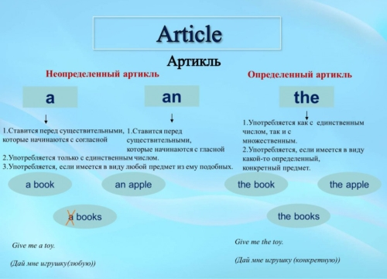**Presentation 1**

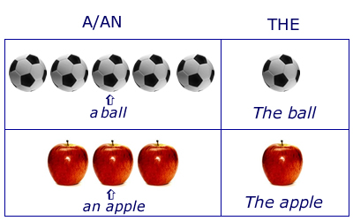**Handout #2**

**Handout #3**

**Cards**

**Interesting fact:**The song Happy Birthday was written by [a, an] pair of school teachers in 1893.

**Interesting fact:**The chicken can travel up to 9 miles [a, an] hour.

**Interesting fact:**   
The longest recorded flight of [a, an] chicken is thirteen seconds.

**Interesting fact:**   
In the wild [a, an] chimpanzee may live to be 50 years old and weigh up to 121 pounds.

**Interesting fact:**   
When [a, an] great white shark is born it quickly swims away from its mother and is on his own.

**Interesting fact:**   
A newborn koala is only the size of [a, an] jelly bean.

**Interesting fact:**   
If you put all your blood vessels in [a, an] line, they would stretch around the earth 2 Ã‚Â½ times.

**Interesting fact:**   
You get [a, an] new stomach lining every three days.

**Interesting fact:**   
[a, an] Monarch butterfly is the state insect of Texas.

Ruby and Leigh Ann saw [a, an] bird’s nest.

Greg has [a, an] orange and green sweater.

[A, An] engine pulled [a, an] long train.

Eduardo put up [a, an] target in the field.

There is [a, an] enormous house on [a, an] hill.

Kellye’s family went to [a, an] opera in New York.

**Site 1**

[**https://www.youtube.com/watch?v=B8MbH5Wwf5I**](https://www.youtube.com/watch?v=B8MbH5Wwf5I)

**Site 2**

[**http://www.eslgamesplus.com/a-an-the-spin/**](http://www.eslgamesplus.com/a-an-the-spin/)

**Handout #6**

**Home task**

1. Colleen and Taylor talked to [a, an] teacher about  [a, an] answer.
2. Jana and Allison had [a, an] art lesson after school.
3. Hayden and got [a, an] home run in the big game.
4. [A, An] exit sign hung over [a, an] door that Andres and Eileen walked
5. Justin had [a, an] aunt and [a, an] uncle for dinner.
6. Shannon ran for [a, an] hour in the park.
7. A.J and Chris had [a, an] cookie and some ice cream.
8. Campbell learned [a, an] Indian dance on [a, an] reservation.
9. [a, an] honest friend is someone to treasure.

**Lesson plan**

**Theme :** Gerund and infinitives.

**Aim :** to teach how to use the gerund and infinitives.

**Objectives:**

-students will be able to know how to use the gerund and infinitives;

-students will be able to develop their communicative skills;

-students will be able to differentiate between gerund and infinitive sentences with the same and different meanings.

**Level:** 8th grade

**Time:** 45 min.

(see the materials in appendice D)

|  |  |  |  |  |  |
| --- | --- | --- | --- | --- | --- |
| **№** | **Stage** | **Instruction/ Procedure** | **Time** | **Material** | **Notes** |
| 1 | Engage | Greetings | 3 min |  | Greet each other. |
| 2 | Engage | Teacher shows to pupils a video about gerund and infinitives after teacher give them cards with rules | 7 min | Site 1  Handout #1  Handout #2 | Pupils should to listen carefully. |
| 3 | Study -game | In this case pupils play game. Teacher explain them rules | 10 min | Handout #3  Handout #4  Handout #5 | Pupils share in 2 taem. |
| 4 | Study - game | In this game teacher use internet resources. This game like a Russian “Pole chudes’’. Each group receive 100 points for every correct answer | 20 min | Site 2 | Pupils should work in 4 groups. They should to answer the question. |
| 5 | Activate | In this case teacher give pupils the questionary and after task teacher should to listen to the pupils. | 5 min | Handout #6 | Pupils answer the questionary, after they should discuss about what activities do they like. |

**APPENDICE D**

**Site 1**

[**https://www.youtube.com/watch?v=h-nI0d94WjM**](https://www.youtube.com/watch?v=h-nI0d94WjM)

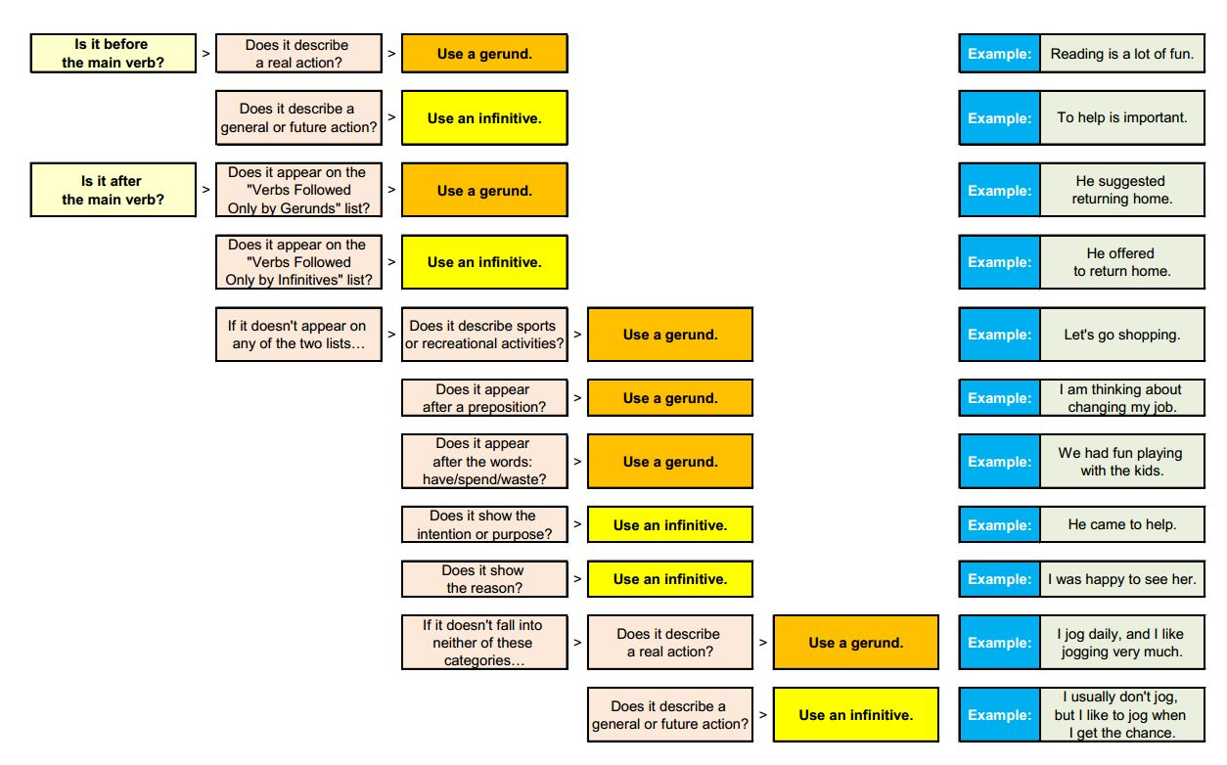**Handout #1**

**Handout #2**

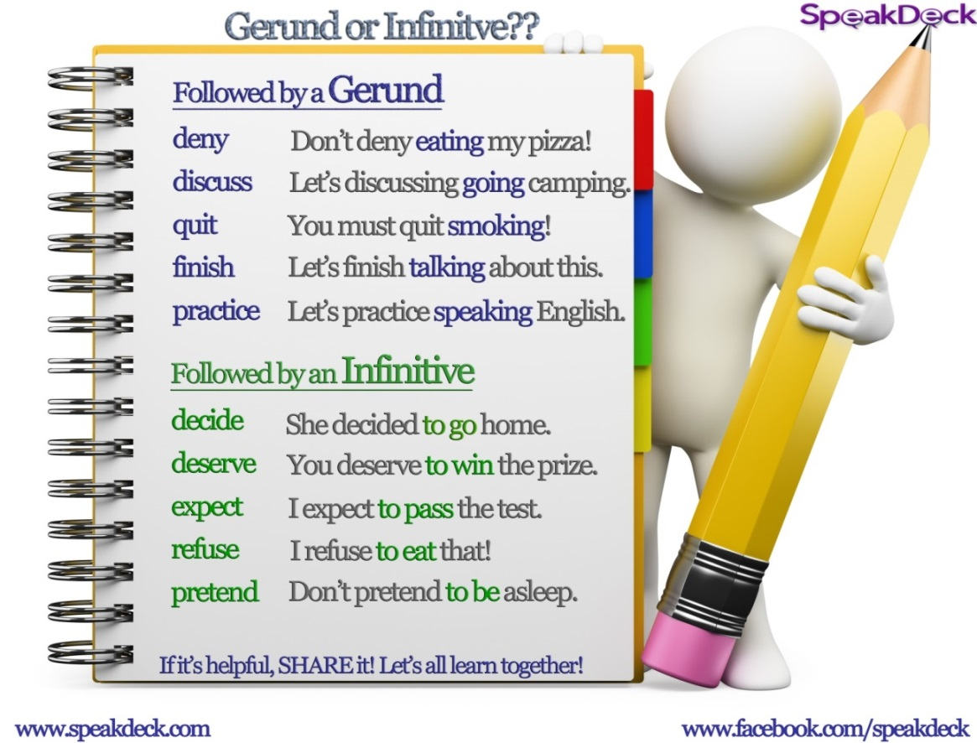

**Rule of game**

**Talking Football**

**Skills to practice:** Practice gerunds and infinitives in a communicative board game.

**Requirements:** Cut out the game resources below. Cut out the balls or players and use as markers

**How to play:**

1. The two teams or players would toss a coin to decide who starts first, or do Rocks, Paper and Scissors. The winner starts combining a cue word and a key word to make sentences. For example regret + inform

*I regret to inform you that you have been fired.*

2. The other team or player must listen carefully to spot the mistakes. If there isn’t any mistake in the sentence, the player can keep his/her space.

3. If there is a mistake the team or player gets a yellow card and move back one step. If no mistake they keep their captured space. The other team takes its turn to combine cue words and keys words to make sentences. Every successful sentence means they retain the space and prepare to advance.

4. Both teams (players) keep advancing until they meet on one space. When they meet they do ROCKS, PAPER and SCISSORS. The team that loses the ROCKS, PAPER & SCISSORS guess, gets a red card and goes back to start. The winning side continues until they meet again. Every time they, meet they do rocks, paper, and scissors to see who gets a red card. The team that gets to the other team’s goal, wins.

5. When players get to the center, it is a FREE space so they can create any sentence

they like.

6. If you decide to continue, try different key words or swap sides after the first side

wins.

7. Feel free to adapt this game for your classes as you like. Also feel free to modify or add rules.

*Tips for large classes:*

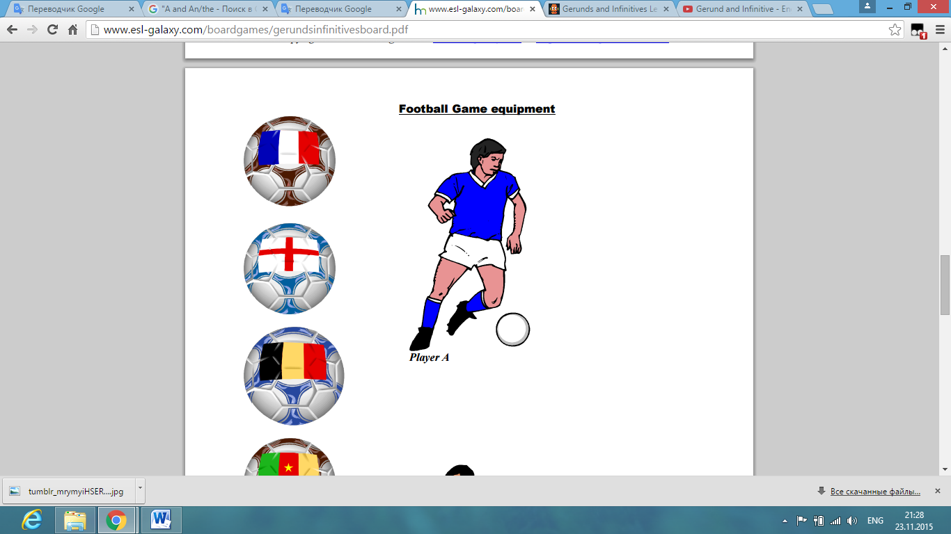This game is a board game, but can also be played in a large class. Photocopy the game on an A3 or larger paper size, or project in on a projector if your class has one. Use blue tag to stick team players as they advanced.**Handout #5**

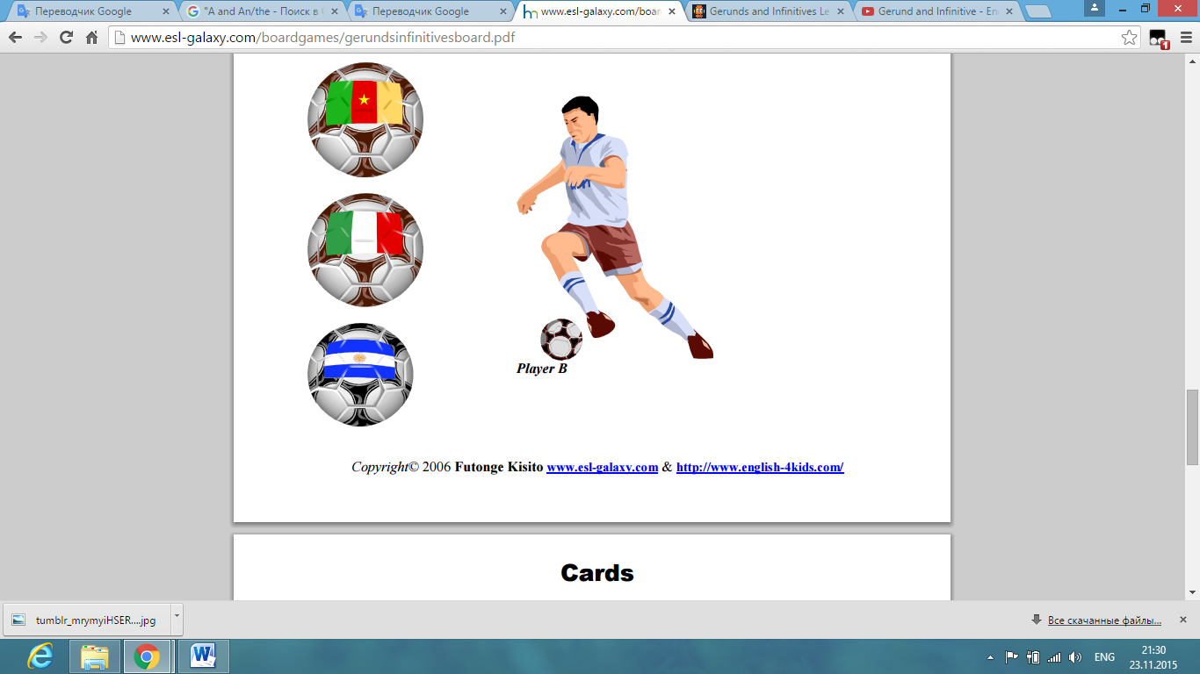

**Handout #6**

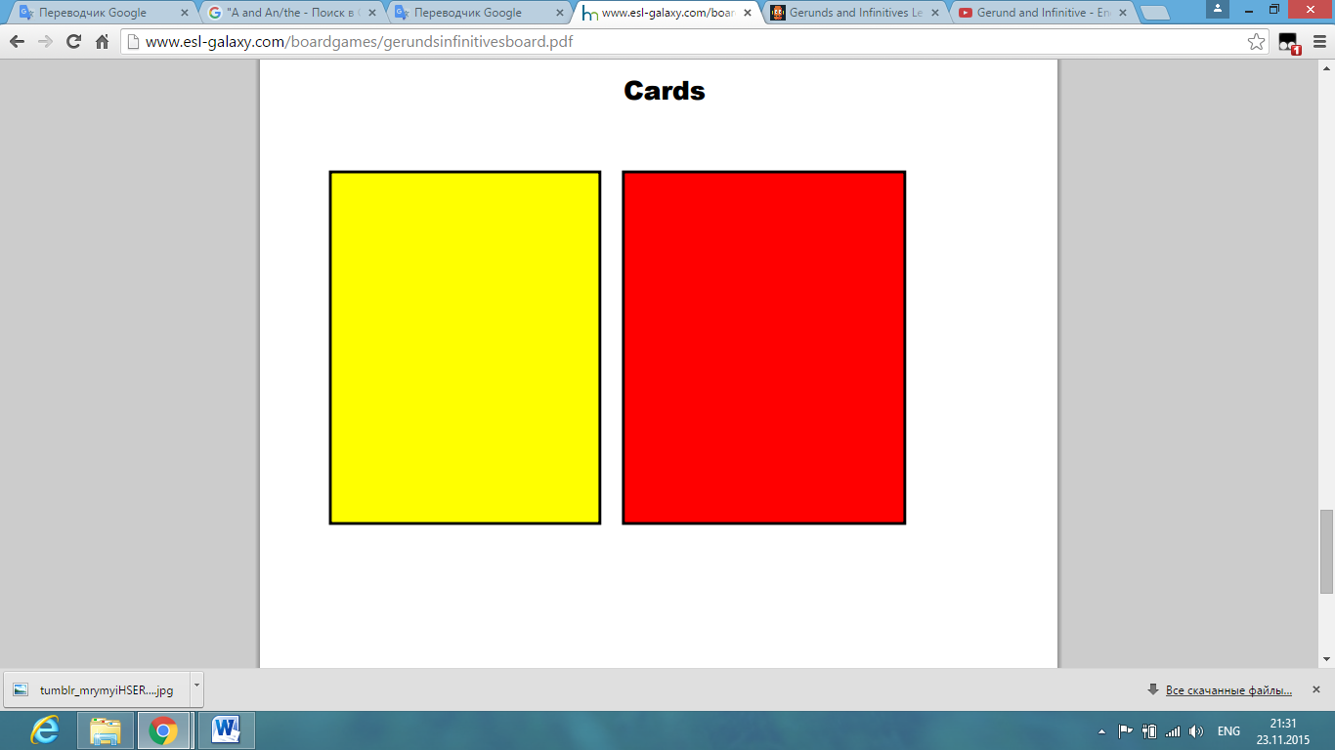

**Site 2**

[**http://www.eslgamesplus.com/ing-gerunds-infinitive-spin/**](http://www.eslgamesplus.com/ing-gerunds-infinitive-spin/)

**Handout #7**

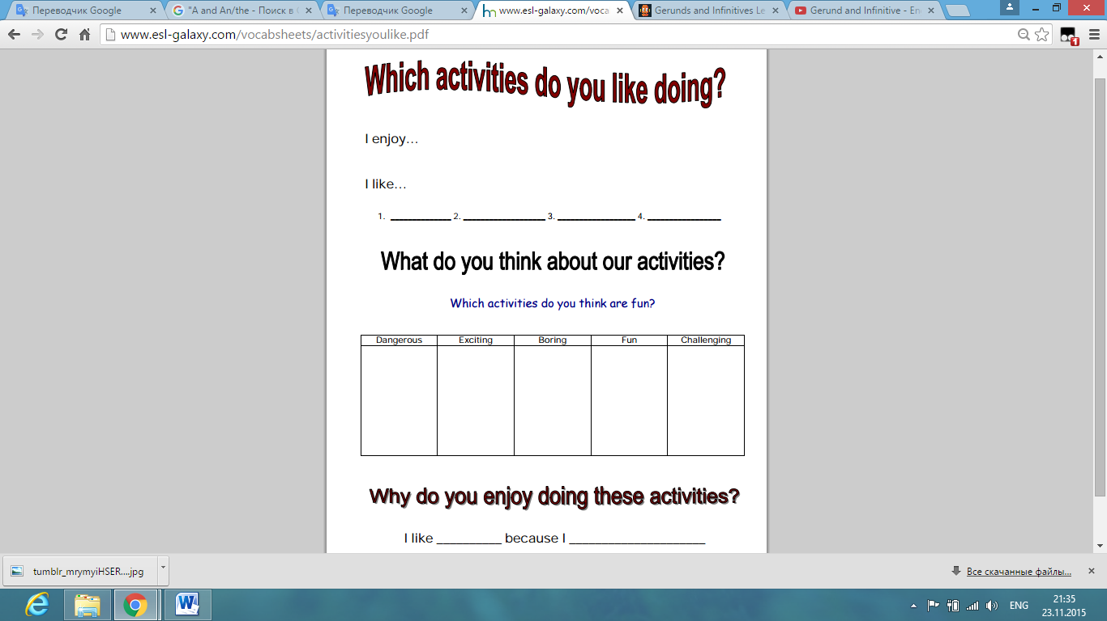

**Lesson plan**

**Theme:** Passive and Active Voice.

**Aim:** to teach how to use the Passive and Active Voice.

**Objectives:**

-students will be able to know how to use the Passive and Active voices;

-students will be able to develop their communicative skills;

-students will be able to differentiate between passive and active voice.

**Vocabulary:** leather, diamond, cotton, japan, steel, Germany, wood, glass, paper,

wool, sheep, plastic, clay, pencil, watch

**Level:** 8th grade

**Time:** 45 min.

(see the materials in appendice e)

|  |  |  |  |  |  |
| --- | --- | --- | --- | --- | --- |
| **№** | **Stage** | **Instruction/ Procedure** | **Time** | **Material** | **Notes** |
| 1 | Engage | Greetings | 3 min |  | Greet each other. |
| 2 | Engage | Teacher shows to pupils a video about passive and active voice after teacher give them cards with rules | 7 min | Site 1  Handout #1 | Pupils should to listen carefully. |
| 3 | Study | Teacher gives pupils cards with exercises. | 10 min | Handout #2 | Pupils should give correct answer. |
| 4 | Study | In this stage teacher gives pupils crossword “What’s it made of?” | 15 min | Handout #3 | Pupils should fill in the gap. |
|  | Study | Teacher gives pupils quiz. | 5 min | Handout #4 | Pupils should chose correct answer |
| 5 | Activate | In this case pupils should to compose 5 sentences where they use two voices. | 5 min |  | Pupils should to do the task and answer the orally. |

**APPENDICE E**

**Site 1**

[**https://www.youtube.com/watch?v=ePfmgMTgXl8**](https://www.youtube.com/watch?v=ePfmgMTgXl8)

**Handout #1**

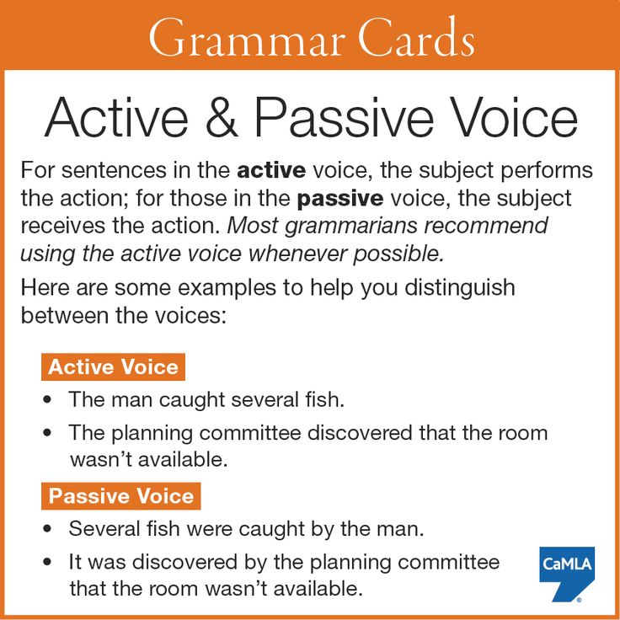

**Handout #2**

1. They often **listen** to music. →
2. She **is reading** the newspaper now. →
3. These cars **are produced** in Japan. →
4. Alan **teaches** geography. →
5. German **is spoken** in Austria. →
6. Lots of houses **were destroyed** by the earthquake in 1906. →
7. Henry Ford **invented** the assembly line. →
8. The bus driver **was hurt** yesterday. →
9. You **should open** your workbooks. →
10. Houses **have been built**. →

**Handout #3**

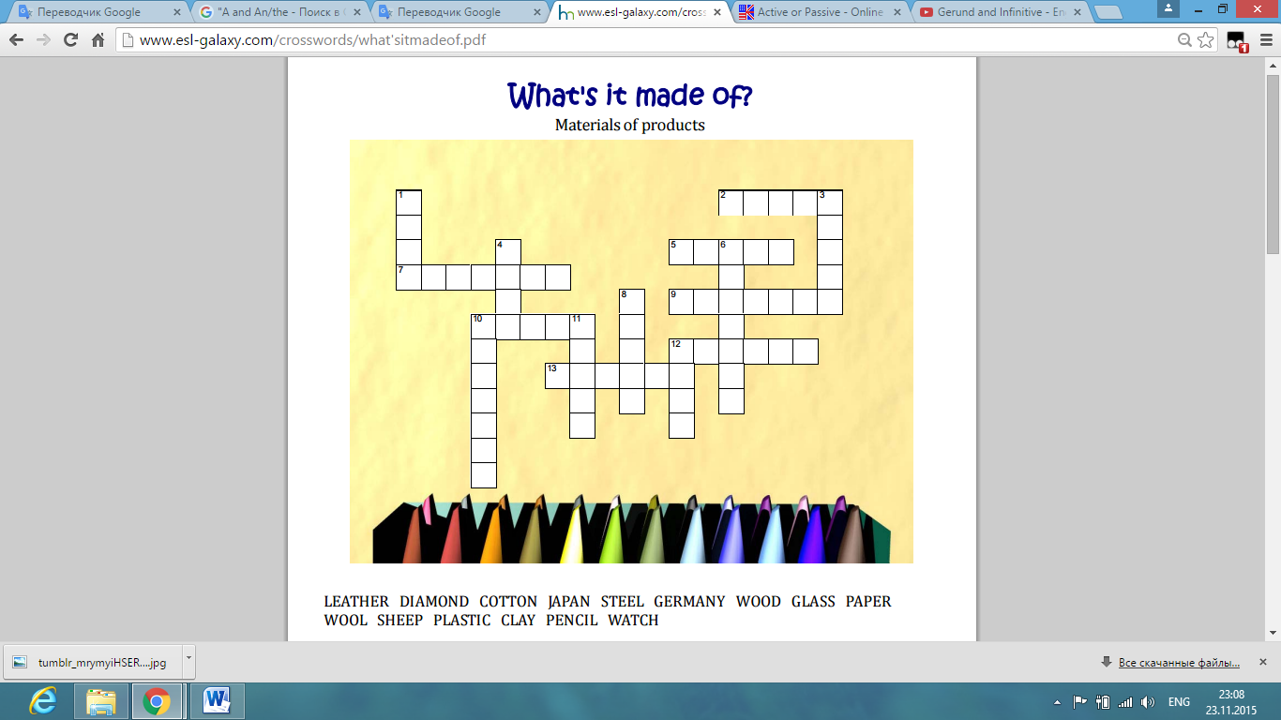

**Across**

2. What animal does wool come from?

5. My SONY TV is made in ________ .

7. Most wedding rings are made of gold and ________.

9. What are most of our shoes made of?

10. What are our TV screens made of?

12. What is your T‐shirt made of ?

13. It is used for drawing and writing and is made of wood.

**Down**

1. What are most tables and chairs made of?

3. It is something we write on which is made of wood.

4. What are sweaters made of?

6. What are most shopping bags made of?

8. It is used for telling the time and is usually made of glass, iron and silver.

10. Where are BMW and Mercedes cars made?

11. Cars are made of iron and _______ .

12. Some teapots are made of iron and silver. Others are made of ______ .

**Handout #4**

**1. Everybody ___ by the terrible news yesterday.**

shocked

was shocked

1. **Mr. Green ___ at the University since 1989.**

has been teaching

has been taught

1. **Not much ___ about the accident since that time.**

has said

has been said

1. **A new book ___ by that company next year.**

will publish

will be published

1. **He ___ the girl's name now.**

remembers

is remembered

1. **The secretary ___ to her new boss yesterday.**

introduced

was introduced

1. **Our plan ___ by the members of the committee.**

is being considered

is considered

1. **He ___ responsible for the accident.**

was holding

was held

1. **A prize ___ to whoever solves this equation.**

will be giving

will be given

1. **When the manager arrived, the problem ___ .**

had already been solved.

had already solved.