ПСИХОЛОГИЯ ДЕТСКОГО РИСУНКА: КАКИМ ЦВЕТОМ РИСУЕТ ВАШ РЕБЁНОК?

[](https://ok.ru/dk?cmd=PopLayerPhoto&st.layer.cmd=PopLayerPhotoOuter&st.layer.type=GROUP&st.layer.revNav=off&st.layer.limitedUi=false&st.layer.sphotoIds=854920148404%3B854920148660%3B854920148916%3B854920149172%3B854920149428%3B854920149684&st.layer.showNav=on&st.layer.photoAlbumId=52069831934132&st.layer.epm=off&st.layer.photoId=854920148404&st.layer.opl=off&st.layer.navStartPhotoId=854920148404&st.layer.sbd=off&st.cmd=userMain&st._aid=GroupTopicLayer_openPhotoLayer)

[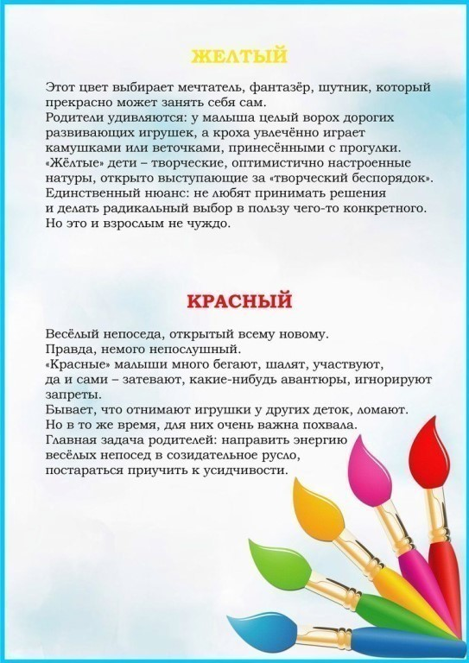](https://ok.ru/dk?cmd=PopLayerPhoto&st.layer.cmd=PopLayerPhotoOuter&st.layer.type=GROUP&st.layer.revNav=off&st.layer.limitedUi=false&st.layer.sphotoIds=854920148404%3B854920148660%3B854920148916%3B854920149172%3B854920149428%3B854920149684&st.layer.showNav=on&st.layer.photoAlbumId=52069831934132&st.layer.epm=off&st.layer.photoId=854920148660&st.layer.opl=off&st.layer.navStartPhotoId=854920148660&st.layer.sbd=off&st.cmd=userMain&st._aid=GroupTopicLayer_openPhotoLayer)

[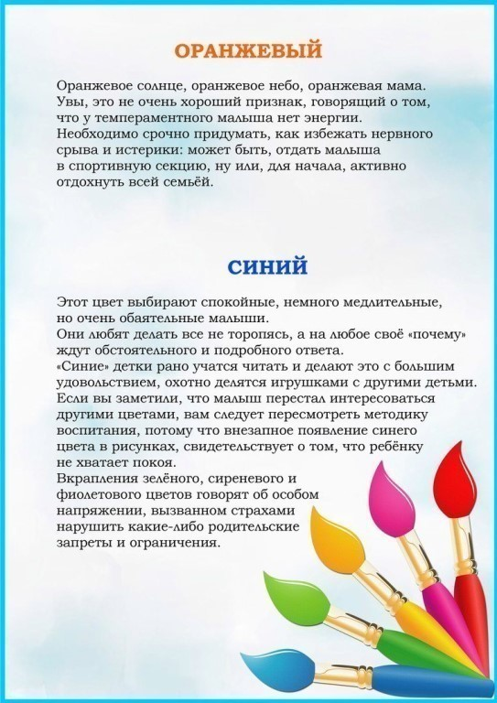](https://ok.ru/dk?cmd=PopLayerPhoto&st.layer.cmd=PopLayerPhotoOuter&st.layer.type=GROUP&st.layer.revNav=off&st.layer.limitedUi=false&st.layer.sphotoIds=854920148404%3B854920148660%3B854920148916%3B854920149172%3B854920149428%3B854920149684&st.layer.showNav=on&st.layer.photoAlbumId=52069831934132&st.layer.epm=off&st.layer.photoId=854920148916&st.layer.opl=off&st.layer.navStartPhotoId=854920148916&st.layer.sbd=off&st.cmd=userMain&st._aid=GroupTopicLayer_openPhotoLayer)

[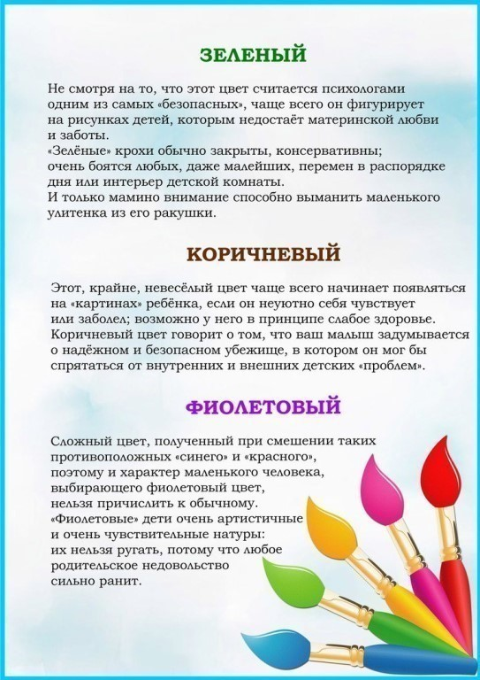](https://ok.ru/dk?cmd=PopLayerPhoto&st.layer.cmd=PopLayerPhotoOuter&st.layer.type=GROUP&st.layer.revNav=off&st.layer.limitedUi=false&st.layer.sphotoIds=854920148404%3B854920148660%3B854920148916%3B854920149172%3B854920149428%3B854920149684&st.layer.showNav=on&st.layer.photoAlbumId=52069831934132&st.layer.epm=off&st.layer.photoId=854920149172&st.layer.opl=off&st.layer.navStartPhotoId=854920149172&st.layer.sbd=off&st.cmd=userMain&st._aid=GroupTopicLayer_openPhotoLayer)

[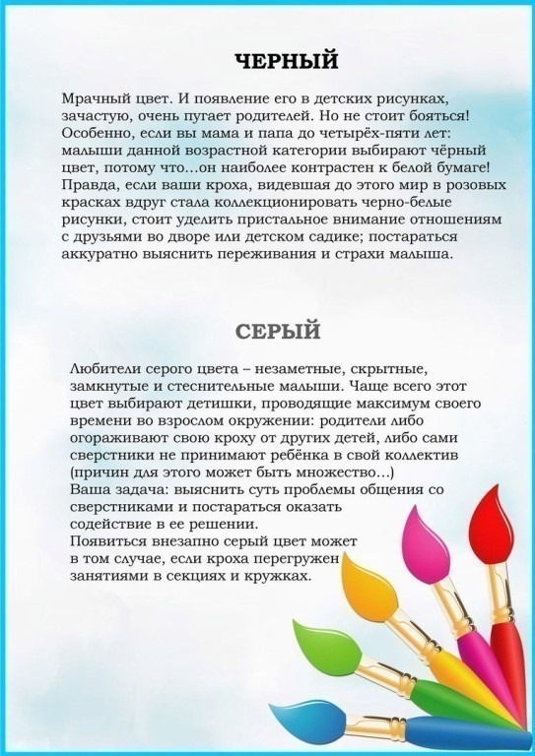](https://ok.ru/dk?cmd=PopLayerPhoto&st.layer.cmd=PopLayerPhotoOuter&st.layer.type=GROUP&st.layer.revNav=off&st.layer.limitedUi=false&st.layer.sphotoIds=854920148404%3B854920148660%3B854920148916%3B854920149172%3B854920149428%3B854920149684&st.layer.showNav=on&st.layer.photoAlbumId=52069831934132&st.layer.epm=off&st.layer.photoId=854920149428&st.layer.opl=off&st.layer.navStartPhotoId=854920149428&st.layer.sbd=off&st.cmd=userMain&st._aid=GroupTopicLayer_openPhotoLayer)

[](https://ok.ru/dk?cmd=PopLayerPhoto&st.layer.cmd=PopLayerPhotoOuter&st.layer.type=GROUP&st.layer.revNav=off&st.layer.limitedUi=false&st.layer.sphotoIds=854920148404%3B854920148660%3B854920148916%3B854920149172%3B854920149428%3B854920149684&st.layer.showNav=on&st.layer.photoAlbumId=52069831934132&st.layer.epm=off&st.layer.photoId=854920149684&st.layer.opl=off&st.layer.navStartPhotoId=854920149684&st.layer.sbd=off&st.cmd=userMain&st._aid=GroupTopicLayer_openPhotoLayer)