***Grade****: 2*

***Date****: 15.12*

***The theme of the lesson:****Christmas with Ben.*

***The aims of the lesson:***

* *organize and synthesize the knowledge of students on the theme " Christmas with Ben "*
* *develop the skills of listening , reading, speaking on the theme ;*
* *creating an atmosphere of creative interaction between students ;*

***Method of the lesson:****Answer the questions*

***Visual aids of the lesson:****:CD disk, smiles, workbook, flashcards*

***The procedure of the lesson***

***I.Organization moment***

***Greeting.***

*T:   Hello, boys and girls!*

*I’m very glad to see you now!*

*Ps: Hello, glad to see you too.*

*T:   Today we are having lots of guests. They are teachers of our school.*

*Greet them, please.*

*Ps: Good morning, dear teachers.*

*T:   Thank you. Sit down, please. You are all very polite.*

***II. Work with books.***

*Our theme in our lesson is “Holidays in England”*

*Ex1. Listen and read.****Track 28.***

***Christmas in England.***

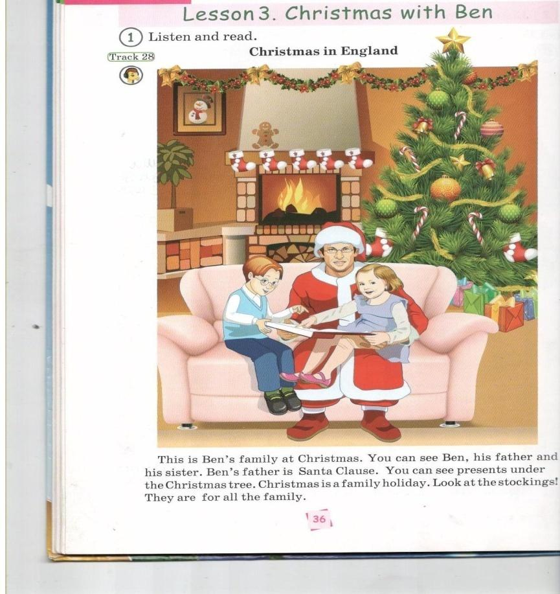

*This is Ben’s family at Christmas. You can see Ben, his father and his sister. Ben’s father is Santa Clause. You can see presents under the Christmas tree. Chrismas is a family holiday. Look at the stockings! They are for all the family.*

***III. Warming-up***

*Let’s sing a song.*

*Jingle bells, jingle bells, jingle all the way!  
O what fun it is to ride in a one-horse open sleigh.  
Jingle bells, jingle bells, jingle all the way!  
O what fun it is to ride in a one-horse open sleigh.*

*Ex2. Listen and read.****Track 29.***

***New Year in Kazakhstan.***

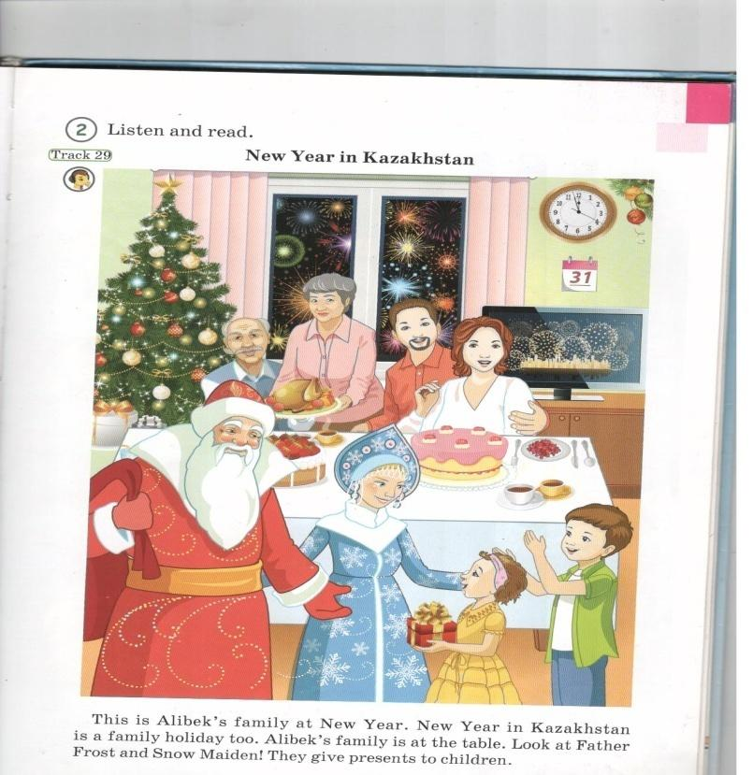

*This is Alibek’s family at New Year. New Year in Kazakhstan is a family holiday too. Alibek’s family is at the table. Look at Father Frost and Snow Maiden! They give presents to children.*

***IV.Conclusion.***

*Thank you, Children. You have got only excellent marks. Please, listen to Christmas carols. It will be your homework.*

*The bell has gone Stand up! Good buy. See you soon.*

***Check:***

The plan of the lesson

***Grade****:*

***Date****:*

***The theme of the lesson:***Sport

***The aims of the lesson:***

*- To introduce pupils with new words connected with the theme «Sport»*

*- To develop the pupils’ skills in using the new words on the theme.*

*- To bring up to help each other, be interested in sport.*

***Method of the lesson:****Answer the questions*

***Visual aids of the lesson:****:CD disk, smiles, workbook, flashcards*

***The procedure of the lesson***

***I.Organization moment***

*- Hello, children! I’m glad to see you. How are you?*

*- Hello, teacher! We are glad to see you. We are fine, thanks.*

***Phonetic ex.***

*Listen and repeat after me: Chess,chalk,chair,chat,champion. Join, jelly,John,jam,jeans. (Pupils will repeat after the teacher).*

***II. Work with books.***

*Our theme in our lesson is “Sport”.*

*Ex1. Listen and learn the new words.*

*Football – футбол*

*Basketball – баскетбол*

*Hockey – хоккей*

*Skating – сырғанау*

*Ex2. Let’s sing a song “Football” Track 31. Remember some words connected with sport.*

*Ex3. Listen and read.*

***III. Warming-up***

*Autumn is yellow.*

*Winter is white.*

*Spring is green.*

*Summer is  bright..*

*Ex4. Read and tell your classmates about yourself.*

*PHONICS.*

*ck hockey duck black sock*

***Conclusion.***

*So, today, we knew about parts of body.*

*Thank you for your attention! Good-bye!*