**Theme :** ***“Sport”***

**Grade:** 4th

**Objectives of the Lesson**:

**Aims:**

-to use new words

-to develop pupils skills in speaking, listening, writing in English

-to answer the questions

**Type of the lesso**n**:** new lesson

**Methods of the lesson:** group work, question- answer**,** game, brainstorming, relaxation reflection.

**Visual aids:** computer, active board, cards, smiles, pictures

**Procedure of the Lesson:**

**I. Organization moment**

Good morning teacher!

Good morning pupils!

How are you?

We are fine!

And you?

I’m ok, thank you!

Who is on duty today?

Who is absent?

What is the date today?

What is the day today?

What was your home task?

**II. Warm-up**

**Phonetic exercises**

You take your little hands

And go clap, clap , clap

You take your little hands

And go clap, clap, clap

You take your little hands

And go clap, clap, clap

Clap clap, clap, your hands

You take your little toes

And go tap tap tap

You take your little toes

And go tap tap tap

Your take your little toes

And go tap tap tap

Tap tap tap your toes

You take your little eyes

And go blink blink blink

You take your little eyes

And go blink blink blink

You take your little eyes

And go blink blink blink

Blink blink blink your eyes

**III. Divide pupils into 3 groups with cards**

**IV. Spelling game. “Nine lives”**

Look at the board. Let’s play a spelling game. Try to find our theme. Name the letters.

If you can not find letters, smiley removed from the board.

**V. Brainstorming. Look at the pictures and name these sports and games**

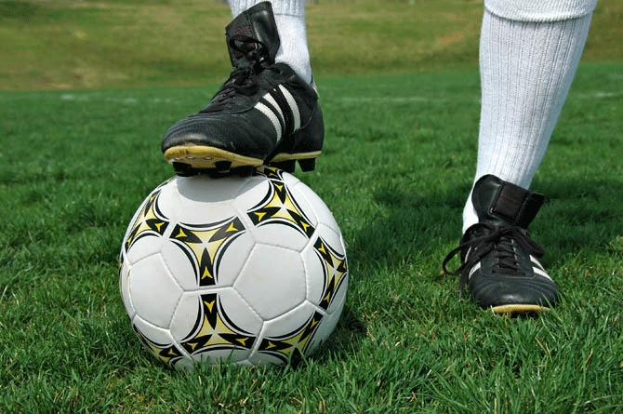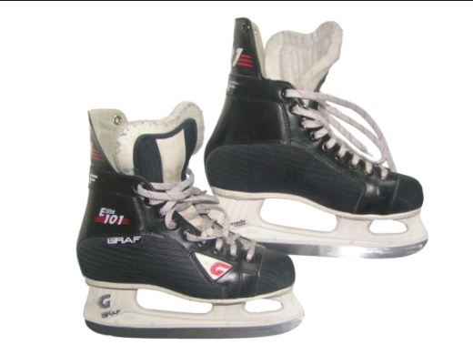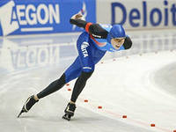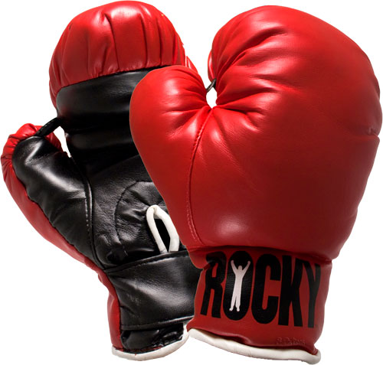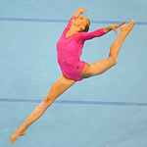

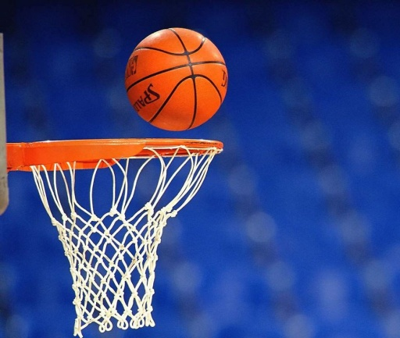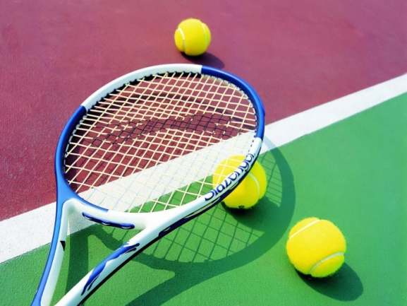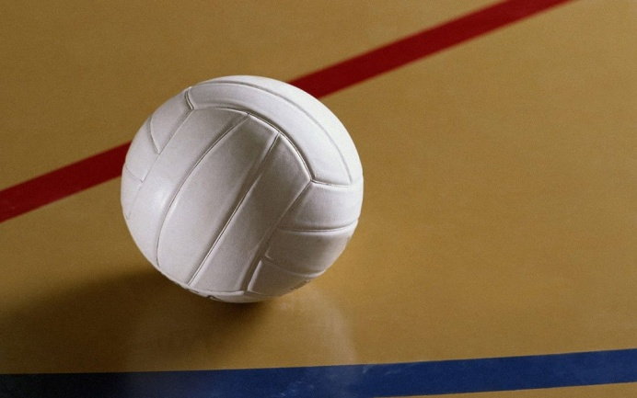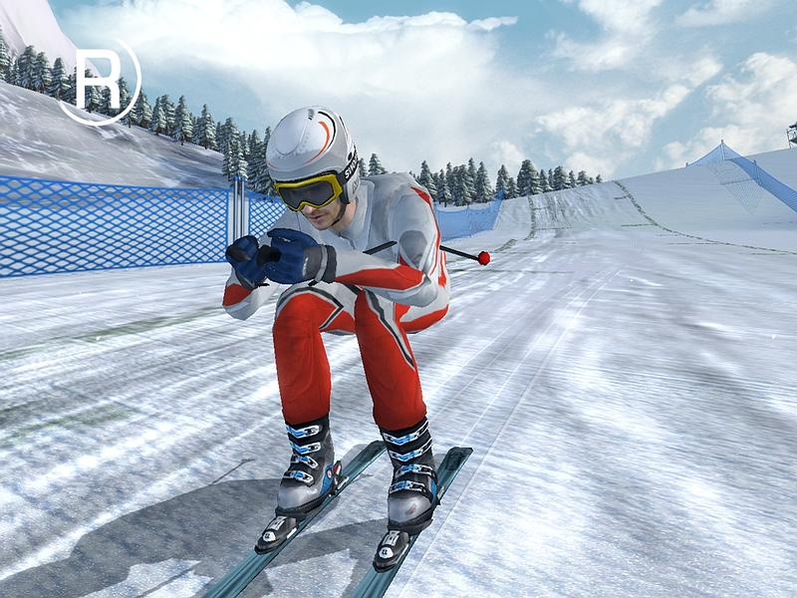[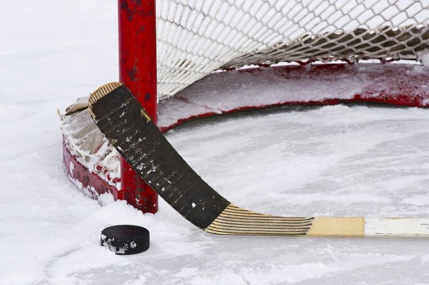](http://www.ventasbalss.ru/upload/news/1316068626.jpg)

**VI. Presentation of new material.**

**Vocabulary new words. Write and repeat them after me**

Football - футбол

Basketball - баскетбол

Volleyball - волейбол

Handball - гандбол

Tennis - теннис

Hockey - хоккей

Boxing - бокс

Jumping - секіру

Skiing - шаңғы тебу

Skating - коньки тебу

Swimming - жүзу

Bowling - боулинг

Horse racing - атпен жарысу

Aerobics - аэробика

Ice hockey - шайбалы хоккей

Golf - гольф

**VII. Answer the questions**

* Do you like sport?
* What sport do you like?
* Do you watch sports on TV?

**VIII. Relaxation. Let’s sing the song**

I can run, I can run  
I can run and run  
And I’m having lots of fun  
I can run, I can run  
Can you?

I can jump, I can jump  
I can jump and run  
And I’m having lots of fun  
I can jump, I can jump  
Can you?

I can swim, I can swim  
I can swim and run  
And I’m having lots of fun  
I can swim, I can swim  
Can you?

I can hop, I can hop  
I can hop and run  
And I’m having lots of fun

I can hop, I can hop  
Can you?

I can skip, I can skip  
I can skip and run  
And I’m having lots of fun  
I can skip, I can skip  
Can you?

**IX. Practice. Match the words**

Football футбол

Volleyball секіру

Tennis бокс

Hockey волейбол

Jumping хоккей

Boxing коньки

Basketball тенис

Aerobics атпен жарысу

Skiing жүзу

skating эробика

horse racing баскетбол

swimming шаңғы

**X. Production. Match the sport and its name**

1. football
2. volleyball
3. basketball
4. handball
5. tennis
6. jumping
7. skiing
8. skating
9. boxing
10. horse racing
11. swimming
12. aerobics

**XI. Reflection.** At the blackboard you see the letters and now can you find me these sports? I’ll show with gestures the sports and you’ll find and write them to the board ok?

|  |  |  |  |  |
| --- | --- | --- | --- | --- |
|  |  | **A** |  |  |
|  |  | **e** |  |  |
|  |  | **r** |  |  |
|  |  | **o** |  |  |
|  |  | **b** |  | **S** |
|  | **B** | **i** |  | **k** |
| ***S*** | ***O*** | ***C*** | ***H*** | ***I*** |
| **k** | **x** | **s** | **o** | **i** |
| **a** | **i** |  | **c** | **n** |
| **t** | **n** |  | **k** | **g** |
| **i** | **g** |  | **e** |  |
| **n** |  |  | **y** |  |
| **g** |  |  |  |  |

**XI. Evaluation and home work:**

You took the medal cards for each task. I ‘ll give you marks with these.

Learn by heart new words.

The lesson is over. Good- bye.