Lesson plan 3-4 form Date:
Form: 4  Theme:  Aims:  Vocabulary/  grammar  Org. moment:  Warm-up:  Checking up of home task:  The main part:  H/t  Sums of the lesson  Reflection.  Marks: | I want to be healthy. Past Simple. Negative form (Простое прошедшее время. Отрицательное предложение)  Уметь составлять отрицательные предложения в Past Simple  Различать утвердительные и отрицательные предложения в Past Simple  Past Simple  T: Good morning, dear children! I’m very glad to see you here. Today we are going to have an interesting lesson. Today we have guests at our lesson. Let's welcome them  Track 2 Hello! (disk 2 form)  Hello, Hello, Hello!  How are you?  I'm fine, I'm great, I'm wonderful  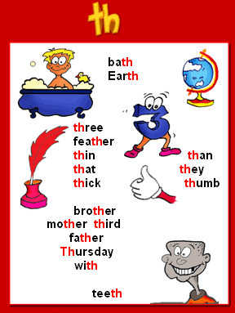  The game : Cross-zero (Questions)  1.Образуйте форму Past Simple от следующих глаголов  go -  do -  clean -  watch -  2. Образуйте отрицательное предложение от  I played basketball yesterday.  3. Как образуется отрицательное предложение в Past Simple?  4. Образуйте отрицательную форму следующих глаголов в Past Simple  had -  read -  wrote -  5. Образуйте отрицательную форму следующих глаголов в Past Simple  cooked -  liked -  looked -  6. Образуйте отрицательное предложение от  I went to school yesterday  1. Independent work  Каждому ученику раздаю бумажные фрукты и овощи, на которых написана отрицательная форма глаголов в Past Simple.(половина из них не правильно образована). По две корзинки(одна для правильно написанных слов и одна для - не правильно)  Task: Divide the words into 2 groups (words: did not get, did not washed, did not had, did not see, did not cleaned, did not cook, did not played, did not look, did not wore, did not write, did not did, did not go, did not like, did not visited, did not clean)  2. Consolidation grammar (метод светофор)  Раздаю ученикам два вида карточек зеленый треугольник и синий квадрат. Зачитываю предложения в Past Simple (утвердительные и отрицательные). Ученики поднимают квадрат если слышат отрицательное предложение и треугольник - утвердительное.  Sentences:  1. She visited her friend yesterday.  2. They did not have a big and tasty breakfast.  3. The child went to bed at 10 p.m.  4. She stayed at her parents’ house.  5. Mary had two sisters.  6. I did not get up so early  7. She did not go to work that morning  8. Children had bread and tea for breakfast.  9. I did not drive to school yesterday  10. I played computer games yesterday  3. Independent work (cards)  Ученикам раздаю карточки с заданием  Task: Rewrite the sentences in Negative form (формативное оценивание)  Ex. 3 p. 23 Rewrite the sentences (Рабочая тетрадь 4 класс, С.Д. Рахимжанова, А.С. Волкова, 2016)  What was the theme of our lesson? What interesting things have you learnt today?  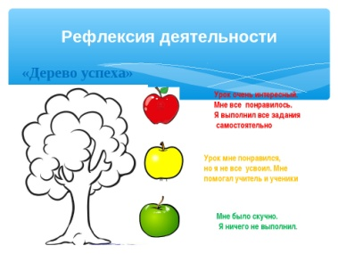  The marks for the lesson are…  The lesson is over! Good-bye! | Form:3  Theme:  Aims:  Vocabulary/  grammar  Org. moment:  Warm-up:  Checking up of home task:  The main part:  H/t  Sums of the lesson  Reflection.  Marks: | What date is it today? Ordinal Numbers (Порядковые числительные)  Называть порядковые числительные на английском языке  Ordinal numbers  T: Good morning, dear children! I’m very glad to see you here. Today we are going to have an interesting lesson. Today we have guests at our lesson. Let's welcome them  Track 2 Hello! (disk 2 form)  Hello, Hello, Hello!  How are you?  I'm fine, I'm great, I'm wonderful  The game : Cross-zero (Questions)  1. Name (назовите) winter months  2. Name (назовите) summer months  3. First autumn month of the year  4. Month between April and June  5. Name (назовите) 4 seasons  6. Name (назовите)12 months  1. Introduction the theme  A) Показываю ученикам картинки и прошу подумать над темой урока. Повторяем количественные числительные от 1 до 20  B) Watching video https://www.youtube.com/watch?v=h_3AI-qNBlE  C) Presentation  1- й first  2-й second  3й third  4-20 й N+th, fourth  Fifth, sixth, tvelfth etc.  2. Independent work (consolidation grammar, cards, формативное оценивание)  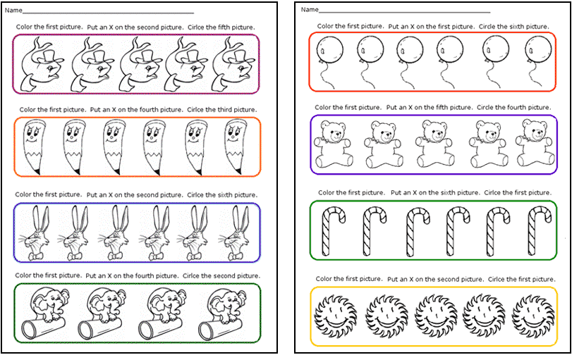  3. Consolidation new theme  A) ученикам даю паровоз и10 разноцветных бумажных вагончиков  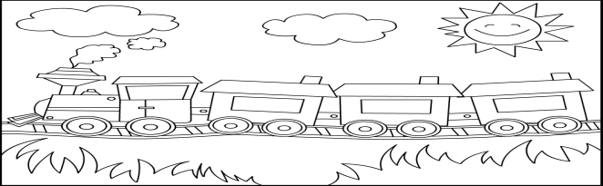  Task 1: Count the railcars using Ordinal Numbers  Task 2: Show (colour) railcar and say its number  B) Watching video (Make a cake)  https://www.youtube.com/watch?v=lQxdX40j9hk&list=RDlQxdX40j9hk  Ex. 1 p. 26. Match the words to the numbers  (Рабочая тетрадь 3 класс, С.Д. Рахимжанова, А.С. Волкова, 2015)  What was the theme of our lesson? What interesting things have you learnt today?  The marks for the lesson are…  The lesson is over! Good-bye!

