The plan of the lesson
Date: 02.09.16
Grade: 7 B
Theme: Parts of the body. Present Simple Tense
The aims:
- Educational: enlarge students' knowledge upon the theme «Parts of the body»
- Educative: to bring up students to be tolerant
- Developing: to develop communicative skills and abilities through different communicative activities

The course of the lesson:
- Organizing moment
- Good morning! I’m glad to see you! Sit down please. Let’s begin our lesson. What is the date today? (The 2nd of September)

- Warm up
- Let's train pronunciation.
- First, I read you listen to me. Let's translate the rhyme. Who can translate?
- I read you repeat after me
- Who wants to read the rhyme?

My Body
10 fingers,
10 toes,
2 eyes
And a little nose.

- Introduction of theme
-Today the theme of our lesson is “Parts of the body”. Please, open your copybooks and write down the date and theme of the lesson

- Open your vocabularies and write down new words

Head | [hɛd]
Neck | [nɛk]
Hand | [hænd]
Leg | [lɛg]
Arm | [ɑːm]
Foot | [fʊt]
Knee | [niː]
Finger | [ˈfɪŋgə]
Toe | [təʊ]
skin | [skɪn]

- Relaxation moment
Head and shoulders
Knees and toes, knees and toes
Head and shoulders
Knees and toes, knees and toes
Eyes, and ears, and mouth, and nose,
Head and shoulders
Knees and toes, knees and toes.

Present Simple Tense

We use the present simple to talk about things we do regularly, or things which are always true.

I go to school every day.
My grandparents live in Manchester.

We add -s to the he, she and it forms.
I sing. She sings.
I drink coffee. She drinks coffee.

- Strengthening

Circle the correct option.

1 We eat / eats fish.
2 They go / goes to school.
3 She read / reads magazines.
4 Jack watch / watches DVDs.
5 You listen / listens to rock music.
6 Pete and Milly play/ plays basketball.
7 My sister live/ lives in a big house.
8 I watch / watches old films.
9 It rain / rains in England.
10 I like/ likes chocolate.

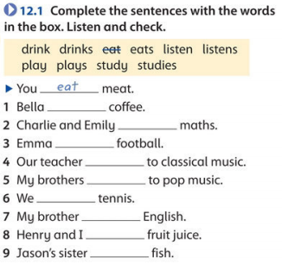

- Home task
-Your home task is to learn the words and make 5 sentences Present Simple

