Date :  Unite:  Theme:  The aim:  Org. moment:  The rules:  Warm-up:  Checking up h/w:  Watching video |  | 27.01.2016  First Conditional  1. To develop pupils’ skills in reading,  writing, grammar, translating, speaking and improve  their logical thinking.  2. Teach pupils to make . First Conditional  3. To bring them up to love English.  The procedure of the lesson:  T: Good morning, dear children! Sit down! Who is on duty today? What date is it today? Who is absent today?  Who can tell me, what day is it today?  Ok, you are right! What season is it now?  How do you do? I hope that you are fine!  Turn off your mobile phone  - Pay attention  - Friendship  - Help each other  - Listen to each others’ ideas  - To come to decision  - Respect each other  - Save the time  Ex complete the sentences  P  How will you teach in the 21st century  Let’s remember our rules  If clause main clause  Present Simple Future Simple  If Mary invites me to her birthday party, I will give her a nice present.  Если Мэри приглашает меня к себе на день рождения, я дам ей хороший подарок  If I have enough time tonight, I will help you.,  Если у меня будет достаточно времени сегодня вечером я помогу вам
The first team “If” |  | .  Complete the sentences.  I will go to the concert if…  If you don`t hurry…  If you go to bed early tonight…  I will turn off the television if…
The second team “Will ” |  | Complete the sentences.  I will go to the concert if…  If you don`t hurry…  If you go to bed early tonight…  I will turn off the television if…
Test  Have a rest!  Work with  Pictures  Закрепление  Home work  Marks |  | Open the brackets and put the verb in the correct form.  I will have a nice dinner if I find some cheese.  If you don’t eat well, mum will be angry with me.  I will read you a book if you sit quietly.  If you guess what animal it is,  you will get a “five” for Biology  If Mr. Smith keeps leaving his  car under my window, the cow  will sleep on it every night.  The man will get  a lot of coconuts if he doesn’t fall down the palm tree.  If you happy  If you angry  If you sleepy  Look at the pictures And make up the sentences  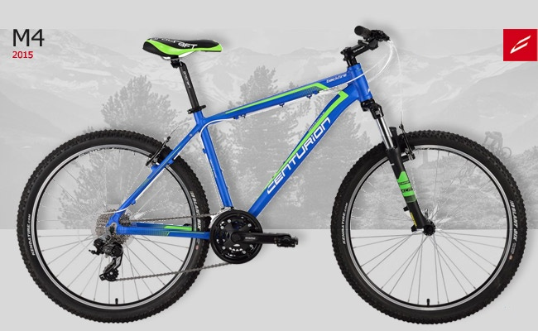  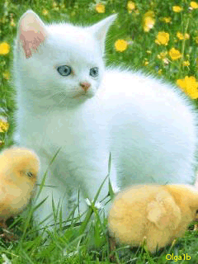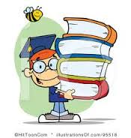  Choose the correct answer.  - If I learn English better ___ English books.  - I will read .  - we buy a new dress.  - she will misses the bus.  2. If she has enough money ___a new dress.  a) she will read.  b) I will speak in English.  c) she will buy.  Ex 4 p 107

