Grade: 5a
The theme: My family
The aims of the lesson:
a) to enlarge pupil’s vocabulary, to pay attention to their pronunciation;
b) to develop pupils’ skills of reading, writing, listening and speaking speech;
c) to develop the interest to English language, to teach pupils to respect each other and the culture of another nations to bring up them to love English language.
The type of the lesson: mixed lesson.
The kind of the lesson: demonstrative lesson.
Visual aids: slides, pictures , an interactive board.

The procedure of the lesson:
I. Organization moment.
а) Greeting
T: Good afternoon, pupils!
P: Good afternoon, teacher!
b) Warm-up
i [ i: ] ee [ i: ]
A little, little bee
is sitting on a tree
because she wants to see
who is busy, who is free?
c) Talking with the pupil on duty.
- Who is on duty today?
Who is absent today?
What is the date today?
What day is it today?
What is the weather like today?

II. Checking up the home task.

Let’s check your hometask.
Ex10, p35.
Count and say.
14-6 = 20-9 = 13-5 =
16-4 = 11-4 = 15-3 =
18-7 = 17-7 = 19-8 =

III. New words.
- Today we have new words linking with the theme family.
- Write down please, these words in your vocabulary.

A grandmother a mother a sister an aunt a son children cousin
A grandfather a father a brother an uncle a daughter parents

IV. Work with pictures.
-Look at the “family tree” and complete the sentences.
1. Ashley is Derek’s …
2. Alan is Brian’s …
3. Jennifer is Ashley’s …
4. Tim is Brian’s …
5. Phyllis is Jennifer’s …
6. Jennifer is Brian’s …
7. Derek is Asley’s …
8. Daphne is Ashley’s …
9. Derek is Brian’s …
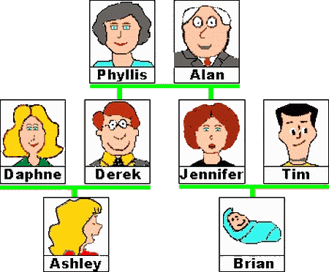
V. Talk to your friend about Ashley’s family.
a) Who is Mr.Alan?
He is ….
b) Who is Jennifer?
She is …
c) Who are Derek and Jennifer?
They are …

VI. Writing - Scrambled Letters
- Find the correct words and write them into the gaps.

Example: horadgmthner - ____________
Answer: horadgmthner – grandmother

1) fathre - 2) necul - 3) aarndgfther - 4) osn - 5) agdtuehr –
6) rbthoer - 7) atnu - 8) nriachgdld - 9) sesitr - 10) othemr -

VII. Singing a song.
- Let’s sing a song which is called “Finger family”.

Daddy finger, daddy finger, where are you?
Here I am, Here I am, how do you do?
Mommy finger, mommy finger, where are you?
Here I am, Here I am, how do you do?
Brother finger, brother finger, where are you?
Here I am, Here I am, how do you do?
Sister finger, sister finger, where are you?
Here I am, Here I am, how do you do?
Baby finger, baby finger, where are you?
Here I am, Here I am, how do you do?

VIII. Word snake.
- Find all family words. Write one word into each gap.

dwgranddaughterdchildgdaughterkkidograndsonvvsonmtwinhtniecehjnephew
qgreatgrandparentsdfathermothergrandmothergrandfatherauntunclechildren

IX. Conclusion.

My father's mother is my ... brother
My mother's father is my ... daughter
My father's daughter is my ... grandmother
My mother's son is my ... aunt
My brother is my father's ... uncle
My sister is my mother's ... grandfather
My father's sister is my ... sister
My mother's brother is my ... son

X. Giving home task.
- Your home task will be to learn new words and to bring a group picture of your family.

XI. Giving marks.

