9 сынып

Сабақтың тақырыбы: Art

Сабақтың мақсаты:

1. Білімділік:

а) Оқушылар өнер тақырыбы бойынша білімдерін молайтады, Past Perfect Tenseқұрылымын қолдануды үйренеді, жаңа сөздермен танысады.

2) Дамытушылық:

б) Сөйлеу тілін дамытады, ағылшын тіліне деген қызығушылығын арттырады.

3) Тәрбиелік:

с) Оқушылар басқа мемлекеттердің мәдениетін құрметтеуге тәрбиеленеді.

Сабақ әдісі: Топпен жұмыс, жұппен жұмыс, сұрақ-жауап.

Сабақ типі: Жаңа білімді меңгерту.

Көрнекілігі: Тақырыптық презентация, видио,карточкалар.

Пән аралық байланыс: Дүние жүзі тарихы, қазақ тілі.

**Сабақ барысы:**

**Ұйымдастыру:**

а) амандасу

Good morning, boys and girls! I’m very glad to see you. Sit down, please.

б) жоқтарды белгілеу

-Who is on duty today?

-Who is absent today?

**Үй жұмысын тексеру:**

Exercise 7 p 44 Match the words with definitions.

Exercise 9 p45 Мake a project about TV in Kazakhstan and make own program for learning English.

**Сабақтың тақырыбымен, мақсаттарымен танысу:**

Our theme in our lesson is ART.

**Жаңа сабақ:**

**Brainstorming exercise**

1.What is music?

2.What is cinema?

3.What is theatre?

4.What is painting?

5.**Art is long, life is short** what do you think about this proverb?

Today we are going to talk about art. **Art** is a diverse range of [human activities](https://en.wikipedia.org/wiki/Human_behavior) in creating visual, auditory or performing artifacts – [artworks](https://en.wikipedia.org/wiki/Artworks), expressing the author's imaginative or technical skill, intended to be appreciated for their beauty or emotional power. In their most general form these activities include the production of works of art, the criticism of art, the study of the history of art, and the aesthetic dissemination of art.

Let`s watch a video about Art.

So let`s summaries the video what kind of association do you have with the word `art`? Fill it in the gaps.

**Introduction of the grammar material.**

**Past Perfect Tense**

**Had+Ved,V3**

Example: When he **came**in,she**had written** her exercise.(+)

**Had s**he**written** her exercise? (?)

Yes,she**had**.No,she**hadn’t**

She **hadn’t written** the exercise.(-)

**Бекіту:**

**TaskI Read the situations,the tick the right answer.**

1.Two men delivered the bed.I had paid for it.Which came first,

a) the delivery b) the payment

2.The waiter brought our tea.We had already had our soup.Which came first,

a) the tea b) the soup

3.I had seen the film,so I read the book.Which came first,

a) read the book b) see the film

4.The film had ended,so I turned the TV off.Did I turn the TV off

a) after b) before the film ended

5.I had an invitation to the party,but I had planned a trip to the mountains.Which came first,

a) the invitation b)the planning for the trip

**Task II Add a sentence with the Past Perfect.**

1.Mary couldn’t get into the cinema.

(the film/ begin)

The film **had** already **begun**.

2.We got to the station ,but we were late.

(the train/just/go)

3.I didn’t have an umbrella,but I didn’t need it.

(the rain/ stop)

4.I was happy to see my aunt.

(not see/her/for a year)

5.My mum was pleased to see my room.

(just/ clean/ it)

6.My friend invited me to lunch yesterday,but I refused.

( already / eat / my hot -dog)

**Lets play the game LOTO**

You have a mixed cards find the words and its definitions. Then you should stick together each cards.

Fine arts

painting, sculpture, drawing, engraving

Music

classical, popular or commercial, country and folk

**Literature**

[literary merit](https://en.wikipedia.org/wiki/Literary_merit), [ordinary language](https://en.wikipedia.org/wiki/Ordinary_language). [fiction](https://en.wikipedia.org/wiki/Fiction) or [non-fiction](https://en.wikipedia.org/wiki/Non-fiction), [poetry](https://en.wikipedia.org/wiki/Poetry) or [prose](https://en.wikipedia.org/wiki/Prose);

Theatre

tragedy, comedy and drama

Cinema

action, comedy, drama, romantic comedy, horror, science fiction

Music

classical, jazz, rap

Turn around your papers please. We can see the worlds map what do you think why is it the map of the world ?

***Art lives everywhere***

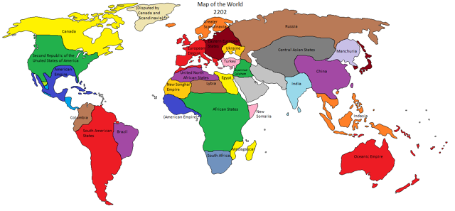

**Қортындылау:**

Thank you. You are very active, attentive and bright. I enjoyed your work at the lesson today. Now assess your partner please. Magic hand

**Үйге тапсырма:**

Exercise 6,7 p 49-50

Сасан би атындағы орта мектеп» КММ

Ашық сабақ

Art

Өткізген : Бейлғожина Г.

2015-2016 оқу жыл