**Урок «Air pollution”**

**Цели урока:**

* совершенствование знаний учащихся по теме
* закрепление умений и навыков использования информационных и коммуникационных технологий в работе обучающихся по теме “Airpollution” на английском языке

**Задачи урока:**

Образовательные:

- Повторить и обобщить лексический материал по теме «Экология, загрязнение»;

- Совершенствовать навыки устной речи, аудирования, развивать способности владения английским языком в дискуссии экологических проблем;

Развивающие:

- Формировать умение работать в группе, в классе;

- Повышать интерес к английскому языку;

- Расширять кругозор учащихся об экологических проблемах, а именно загрязнение воздуха;

- содействовать развитию аналитического, критического, латерального мышления, посредством применения проблемных ситуаций.

Воспитывающие:

- Прививать школьникам любовь и уважительное отношение к природе,

- вырабатывать способность понять экологические проблемы и желание помочь природе

- воспитывать в учащихся ответственность за природу.

- поддерживать дух толерантности, принимая другие точки зрения;

**Тип урока**: комбинированный и повторительно-обобщающий.

**Методы обучения:** изложение проблемы, исследовательский, коммуникативный, дифференцированный и интегрированный.

**Оборудование:** интерактивная доска, проектор, карточки с заданиями, видеоклип с песней Michael Jackson “The Earth Song” с текстом слова для учащихся УМК Т.А. Аяпова, З. Абильдаева, учебник «Английский язык», 2015 год, Алматы мектеп.

**Ход урока:**

Вступительное слово учителя.

Today it is an remarkable lesson. As today we will be talking about important issue of our city and not only – air pollution.

First, look at the board and discuss the following questions:

1. What do you see by looking around?

2. How does pollution destroy our atmosphere?

3. Please give an example of using the nature

4. Do you know any ecological disasters?

5. Could anything reimburse the harm on the natural environment?

6. What can one do to protect the environment?

7. What is the main task for us people?

Представление новой лексики

Please have a look at new vocabulary for you today. Write them down on your dictionary.

What do these words mean? Please give definition in English.

|  |  |  |
| --- | --- | --- |
| New word | Translation | Definition |
| Nature | природа | The phenomena of the physical world collectively, including plants, animals, the landscape, and other features. |
| Attitude | отношение | A settled way of thinking or feeling about something |
| habitat | Естественная среда | The natural home or environment of an animal, plant, or other organism |
| Smell | чувствовать запах | The faculty or power of perceiving odours or scents by means of the organs in the nose |
| acid rain | Кислотный дождь | A rain that contains acid from industrial waste |
| Reveal | открывать, показывать | Make (previously unknown or secret information) known to others |
| recycling | переработка | Convert (waste) into reusable material |
| Global warming | Глобальное потепление | A gradual increase in the overall temperature of the earth’s atmosphere generally attributed to the greenhouse effect. |
| Impact | влияние, влиять | The action of one object coming forcibly into contact with another |
| Scope | объем | The extent of the area or subject matter that something deals with or to which it is relevant |
| Deforestation | вырубка леса | The action of clearing a wide area of trees |
| Pollution | загрязнение | The presence in or introduction into the environment of a substance which has harmful or poisonous effects |
| Deterioration | ухудшение | The process of becoming progressively worse |

Чтение и работа с текстом

Read the text and mark the information which is new to you.

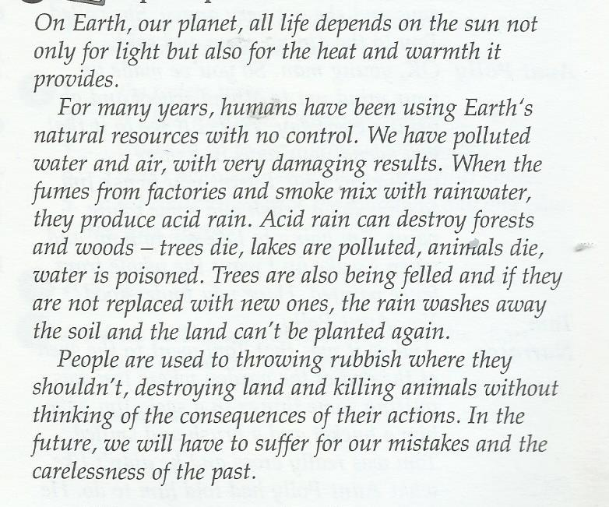

1. Answer the questions
2. What determines life on Earth? ______________________________________
3. How long has man damaged the planet? __________________________________
4. What produces acid rain? ___________________________________________
5. Why is acid rain dangerous? ___________________________________________
6. How can we change this situation? ________________________________________
7. Complete the sentence with your own examples. Use second conditional
8. If we protected the environment, _____________________________________
9. Acid rain wouldn’t be a problem if_________________________________
10. If laws were stricter _________________________________________
11. To help the environment I’m ________________________________
12. My family and I aren’t _______________________________________
13. Label the pictures with the words from the box

**land pollution** / **water pollution** / **air pollution** / **noise**

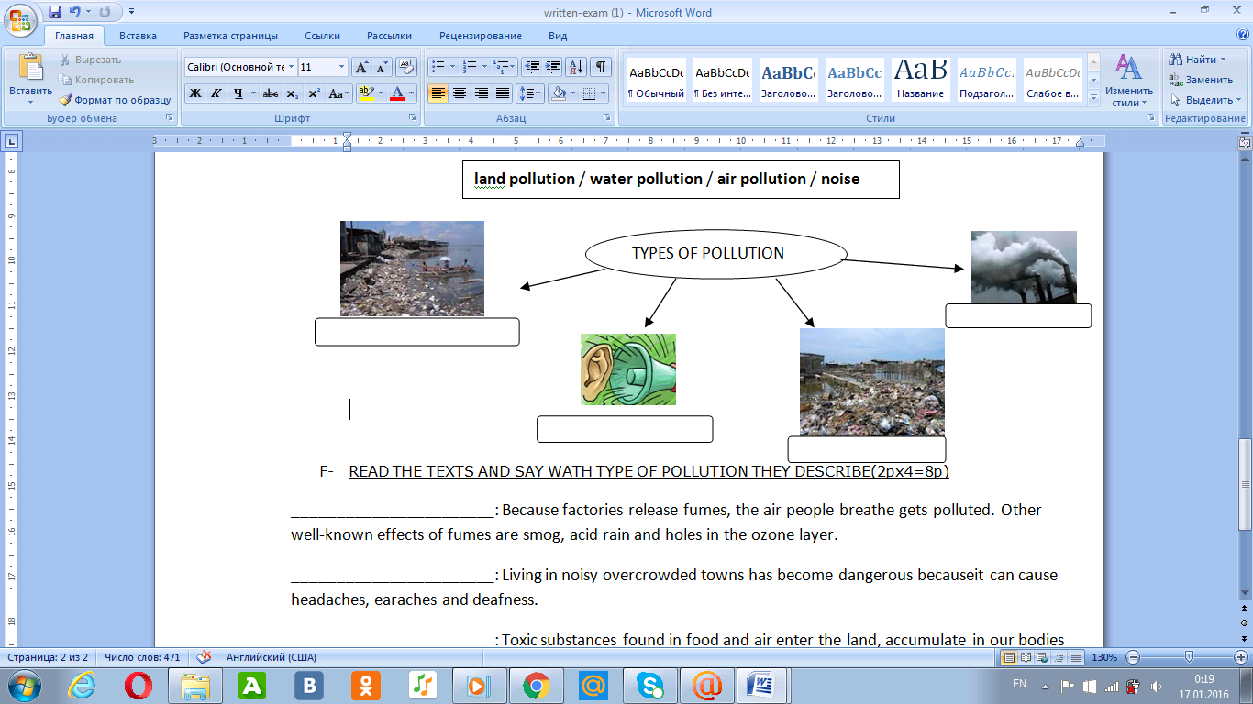

1. Read the definitions and say what type of pollution they describe.

_______________________: Because factories release fumes, the air people breathe gets polluted. Other well-known effects of fumes are smog, acid rain and holes in the ozone layer.

_______________________: Living in noisy overcrowded towns has become dangerous becauseit can cause headaches, earaches and deafness.

_______________________: Toxic substances found in food and air enter the land, accumulate in our bodies and result in poor health like weakness, pains, aches disease and sickness.

_______________________: Toxic chemicals, dirt and trash found in the water hurt the skin of people swimming in them, kill sea animals, produce horrendous smell, etc.

Классное чтение

Increasing level of smog and density of airborne in Almaty caused bad influence on Almaty environment and health of Almaty citizens. There are different reasons that cause air pollution. The main sources of human-made air pollution include automobiles, combustion of solid fuels for cooking, heating, poor environmental regulation and age and poor maintenance of vehicles. Air pollution in Almaty is caused by several reasons. Firstly, incinerators and waste disposals, forest and agricultural fires from natural sources of air pollution. Secondly, transport emissions cause air pollution in the city. Researches states that 80% of air pollutions in this city are transport emissions. This happens because, as statistics of the Almaty traffic police shows, the number of cars reached 500,000 at the end of 2011 and continues to increase yearly. Thirdly, incorrect town building is another reason why Almaty is one of the most air polluted cities in the world. All this reasons lead Almaty to be on the ninth place on the list of the worst air polluted cities over the world by the World Health Organization. The population of this city, mostly those, who live in the lower part of the city, suffer heavily from air pollution. For example, people who live in air polluted area have serious health problems connected with respiratory diseases.

***Task:*** Give your ways to solve the problem with air pollution in Almaty city. Please use second conditional to make your suggestions.

Discuss in group of three your ideas.

**Аудирование**

Now I please listen to the song of Michael Jackson “The Earth Song”.

First you will watch and listen to the song without lyrics. (*<https://www.youtube.com/watch?v=XAi3VTSdTxU>* )

What is the song about?

Now here are your lyrics of this song. If you know the lyrics please sing along.

Парная работа

We have reviewed so many vocabulary today. Now I want you get in pairs and solve the given crossword. The first pair will get a prize. You may start now.

|  |  |  |  |  |  |  |  |  |  |  |  |  |  |  |  |  |  |
| --- | --- | --- | --- | --- | --- | --- | --- | --- | --- | --- | --- | --- | --- | --- | --- | --- | --- |
|  |  |  |  |  | 1n |  |  | 2d |  |  |  |  |  |  |  |  |  |
|  |  |  |  |  | a |  |  | i |  |  |  |  |  | 7w |  |  |  |
|  |  |  |  |  | t |  |  | s |  |  |  |  |  | a |  |  |  |
|  |  |  |  |  | u |  |  | 4p | o | p | u | l | a | t | i | o | n |
|  |  |  |  |  | r |  |  | o |  |  |  |  |  | e |  |  |  |
|  |  |  |  |  | 3e | m | i | s | s | i | o | n |  | r |  |  |  |
|  |  |  |  |  |  |  |  | a |  |  |  |  |  |  |  |  |  |
|  |  |  |  |  | 5h | 6e | a | l | t | h |  |  |  |  |  |  |  |
|  |  |  |  |  |  | n |  |  |  |  |  |  |  |  |  |  |  |
|  |  |  |  |  |  | v |  |  |  |  |  |  |  |  |  |  |  |
|  |  |  |  |  |  | 8i | n | f | l | u | e | n | c | e |  |  |  |
|  |  |  |  |  |  | r |  |  |  |  |  |  |  |  |  |  |  |
|  |  |  |  |  | 10p | o | l | l | u | t | i | o | n |  |  |  |  |
|  |  |  |  |  |  | n |  |  |  |  |  |  |  |  |  |  |  |
|  |  |  |  |  | 11s | m | o | g |  |  |  |  |  |  |  |  |  |
|  |  |  |  |  |  | e |  |  |  |  |  |  |  |  |  |  |  |
|  |  |  |  |  |  | n |  |  |  |  |  |  |  |  |  |  |  |
| 9r | e | g | u | l | a | t | i | o | n |  |  |  |  |  |  |  |  |

Very good!

Today we had very good discussion about Air pollution. Here are your marks for today…

***Home task***: At home read the text from the book ”Air pollution” and retell it.