*Zhanaozen 2015*

*School №2*

***Open lesson***

*Theme: Celebrating Holidays*

*Made by: Borambaeva Zhaynagul*

Уақыты: 5.03.2015

Оқулық: Аяпова Т. , Әбілдаева З.

Сыныбы: 6 «Б»

Тақырыбы: Celebrating Holidays

Сабақтың мақсаты:

1. Жаңа тақырыпты «Celebrating Holidays» таныстыру. Жаңа тақырыпқа арналған жаңа сөздермен таныстыру.
2. Жаңа тақырыпты бекіту мақсатында кеспе қағаздармен жұмыс жасау және жаттығулар орындау. Тақырыпты қорытындылау мақсатында тес орындау.
3. Оқушыларды сыйластық пен достық сезімге тәрбиелеу. Шет тіліне деген қызығушылығын арттыру.

Сабақтың көрнекіліктері:

1. Жаңа сөздер
2. Фонетикалық жаттығу
3. Кеспелер

Сабақ жоспары:

1. Ұйымдастыру кезеңі
2. Фонетикалық жаттығу
3. Үй жұмысын тексеру
4. Жаңа сөздермен таныстыру
5. Жаңа тақырыппен таныстыру
6. Жаттығулар орындау
7. Сергіту сәті
8. Үйге тапсырма
9. Бағалау
10. Қорытындылау

**Plan of the lesson**

**I. Organization moment:**

**Teacher:** Good afternoon pupils?

**Pupils:** Good afternoon teacher

**Teacher:** Thank you, sit down, please. How are you?

**Pupils:** We are fine. And you?

**Teacher:** I’m Ok, thanks. Who is on duty today?

**Pupils:** I’m on duty today.

**Teacher:** What date is it today?

**Pupils:** Today is the 5th of Match

**Teacher:** Who is absent today?

**Pupils:** All are present.

**Teacher:** What day is it today?

**Pupils:** It is Thursday

**Teacher:** Thank you, sit down, please.

**Teacher:** What season is it now?

**Pupils:** It is spring.

**Teacher:** What the weather like to day?

**Pupils:** Today is sunny and warm.

**II. Phonetic drill:**

**Teacher:** Before the start of the our lesson, I will divide you into three groups. Group entitled “ Helloween”, “Nauryz, and “New Year”. Come to the table and choose one of these cards. The cards shown pictures “asyk”, “ gift boxes” and “pumpkin”. Look at your cards and sit in their groups.

**Teacher:** Today we will have an unusual lesson, because there are many guests in our class room, so let's show them our language skills. Ok, pupils, before beginning our new lesson let’s do this task. Look at the interactive whiteboard. How many English words can you find in the word “Whitewash”? Make as many words as possible. Do not use names.

Whitewash – eat – white – wash – she – he – tea – hate – wish – hash etc.

**Teacher:** Ok, you are great.

**III. Home task:**

**Teacher:** What was your home task?

**Pupils:** Our home task exercise 3 page 217. Choose the right form of the Past Continuous Tense

**Teacher:** Let’s check up your home task. Who wants to begin?

**Pupils:** May I say?

**Teacher:** Yes, you may.

**IV. New words.**

Ok, pupils let’s take our new words. Look at the interactive whiteboard. At first I read then you repeat after to me

Decorate [ ˈdekəreɪt ] сәндеу, безендіру

Chimney [ ˈtʃɪm.ni ] мұржа

Celebrate [ ˈselɪbreɪt ] тойлау

Neighbour [ ˈneɪbə ] көрші

Costume [ ˈkәs.tjuːm ] костюм, киім

Guest [ ɡest ] қонақ

Knock [nɔk] қағу, тарсылдату

Trick [trik] айла, тәсіл

Threat [ θret ] қауіп

Roast [ rəʊst ] қуырылған

Turkey [ ˈtəː.ki ] күркетауық

Pie [pai] бәліш

Sock [sɔk] шұлық

Stocking [ ˈstɔk.ɪŋ ] шұлық

National [ ˈnæʃnəl ] ұлттық, халықтық

Traditional [ trəˈdɪʃnәl ] дәстүрлі

**Teacher:** Ok, pupils open your vocabulary and rewrite new word. You have 5 minutes.

**Teacher:** Have you finished?

**Pupils:** Yes we have

**V. New lesson:**

Teacher: Let’s begin our new lesson. Today’s our new lesson is about Holidays, Traditions and Customs of the English-speaking countries. Open your books at page 118. Then open your copybooks and write the date, day with the theme. So every country and nation has their own traditions and customs. It's very important to know traditions and customs of different countries. There are only 6 public holidays an year in Great Britain ,that is days on which people need not to go for work. They are: Christmas Day , Boxing Day , Good Friday, Easter Monday, Spring Bank Holiday and last Summer Bank Holiday, New Year’s Day. Is also a public holiday and in Kazakhstan there are only 10 public holidays, such as: Mother s Day, Victory Day , Republic Day, the Day of Constitution , Independence Day, the New Year s Day, Ait , Nauryz and etc.

**VI. To do exercises:**

Exercise 2 page 118. Read. Match the holidays with the information.

a)People in Britain celebrate this holiday in January. Sometimes they have parties where guests dress up in costumes and cover their faces masks. Next day people visit friends, relatives, neighbors.

b)It’s a holiday for children in Britain. Children dressed in costumes knock on the neighbors’ door and ask: “Would you like “treat” o trick”? Give them a “treat” (money or sweets). They go away.

c)People celebrate this holiday in March in Kazakhstan. People have “kozhe”, “baursak”, drink “kymyz” and “shubat”. Over 100 nationalities celebrate this holiday. They love it.

d) People in many countries decorate Christmas trees and give each other presents. Children leave a long sock or stocking at the end of the bed on December 24. They hope that Santa Claus will come down the chimney during the night and bring them presents. The special food is a big turkey and Christmas pudding.

Very good.

Exercise 3 page 119. Write. Add these words to the word map

|  |  |  |  |
| --- | --- | --- | --- |
| **Holidays** | **Special foods** | **Things we give and receive** | **Special occasion activities** |
| Parties | A roast turkey | Flowers | Sweets |
|  | Pudding | Gifts | Wear costumes |
|  | Potatoes |  | Cover their faces  with mask |
|  | A pumpkin pie |  | Play trick |
|  |  |  | Knock on the doors |
|  |  |  | Money |
|  |  |  | Decorate |

Exercise 3E page 120. Read the text again complete the sentences

1.Children dressed ______ costumes knock _______the neighbours doors.

2.It you don’t give them sweets or money they play a trick ______ you.

3.They dress ______ costumes and cover their faces ______ masks.

4.They hope that Santa Claus will come ______ the chimney during the night.

5.They gather together ______ a home ______ a traditional dinner.

Find the word

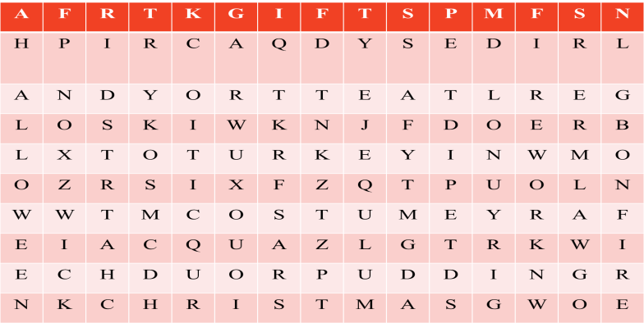

**VII. Homework**

Your homework: How do you get from your house at school. Draw a map and write.

**VIII. Giving marks**

**Teacher:**Dear children! I’m very satisfied with your answer and your taking part to the lesson and all of you worked very well. Your marks will be excellent and good marks. Thank you for your attention.

**IX. Conclusion:**

The lesson is over!

Good bye!

See you soon!