
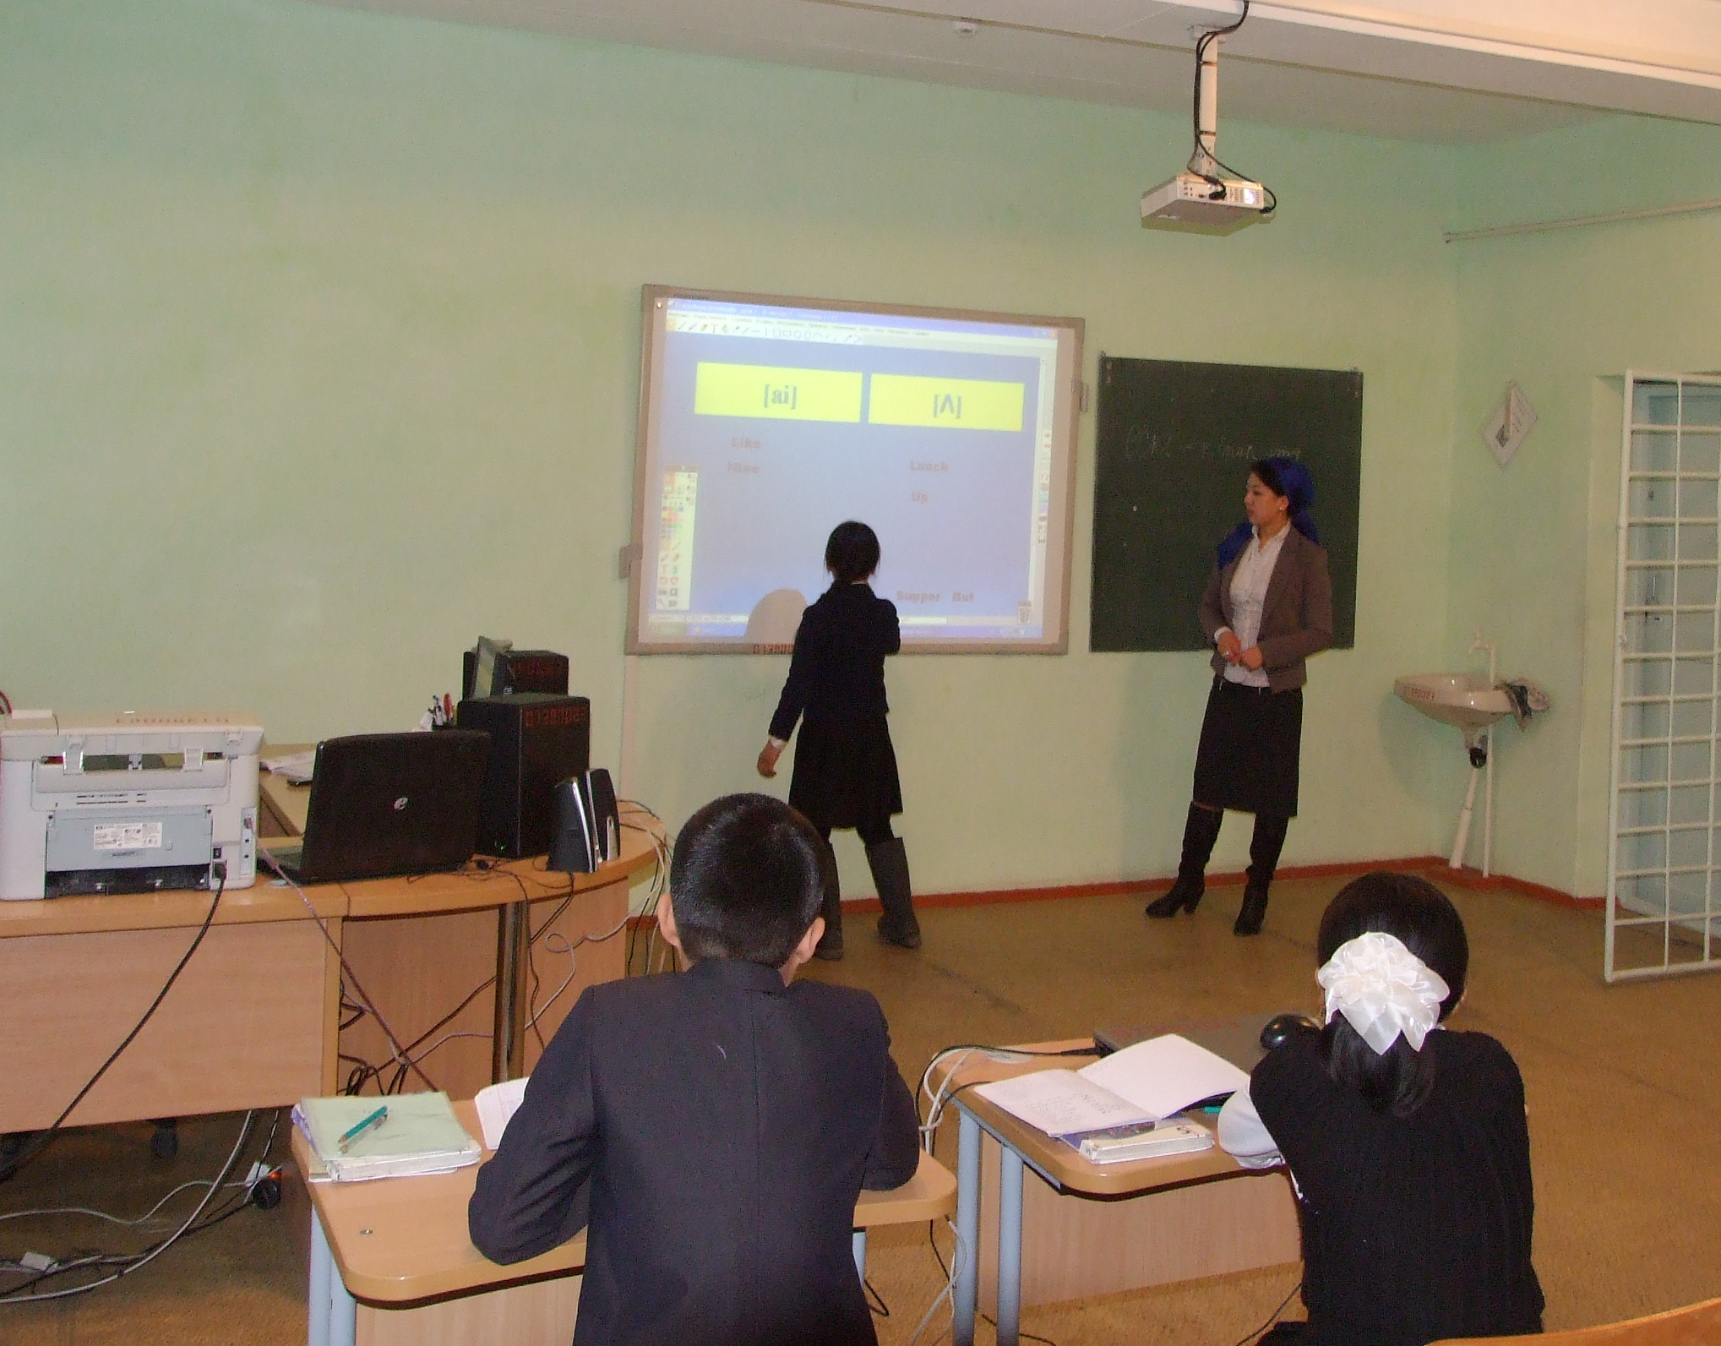

Урок английского языка
в 6 классе
с использованием ИКТ
(2-й год обучения)
учитель: Гарова С.Р.
СШ № 17 с. Сортобе
Кордайский район

Тема: Профессии
1 –
Цель урока: формировать навыки устной речи по теме «Профессии».

Задачи:
Учебные:
- Совершенствовать произносительные навыки.
- Учить дифференцировать в речи вопросы Who is he? What is he?.
- Активизировать в речи лексические единицы предыдущего урока.
- Формировать навыки чтения с поиском заданной информации.
- Познакомить с новыми лексическими единицами.
- Совершенствовать произносительные навыки.

Развивающие
- Развивать самостоятельность мышления.

Познавательные
- Расширять кругозор через ознакомление с реалиями: “Тауэр”, “бифитер”.

Воспитательные
- Воспитывать уважительное отношение к различным видам профессиональной деятельности.

Ход урока
- Orgmoment (1 мин)
Teacher(T): Good morning, students! Nice to meet you. What date is it today? What day of the week is today? What is the weather today? (Учащиеся отвечают на вопросы учителя)
Let`s begin our lesson.
Психологический настрой(1мин) (по кругу учащиеся спрашивают друг друга How are you? I’m fine, thank you and how are your parents? …. Not bad, thank you… etc )

- Деление на группы (1мин) (making mosaic)

- Аудирование. (постановка проблемы) (3 мин)

Teacher: Now, let’s listen to the song
It will be a nice song. Listen to it. …
Teacher: What is this song about?
Yes, we’ll talk about professions today
How many professions are mentioned in this song? Let’s repeat them.
P1: a farmer. и т.д. (a doctor, a teacher, a dentist)

- Фонетическая зарядка (2мин)
There are a lot of tongue twisters where professions are mentioned.
Let’s try to read them
P1: How many cookies could a good cook cook?
P2: A fisherman wished a good fish/
P3: She saw Sheriff’s shoes on the sofa.
P4: Rony the warrior and Roger the warrior were very brave.
P5: The Queen in green screamed.
P6: Singer Sammy sang songs.
P7: Editor Eddy edited it.

- Revision
1) Grammar revision (4)
Teacher: Now I want to concentrate your attention on the following thing. Look at the blackboard, please. You can see a pair of questions:
1 – Who is he? 2- What is he? What do we mean asking these questions?
P1: When we ask “Who is he?” we mean the name of the person.
P2: When we ask “What is he?” we mean the job of the person.
Teacher: Now find questions – synonyms:

P1“What is his name?” P2“What is his Job?”

Teacher: Right. Now you know that people can ask about the same things in different ways. Let’s do an exercise in which you are to match the questions that have the same meaning.
Work in group

A) What is his name? a ) What is your name?
B) What is he? b) Who is he?
C) Who are they? c) What are their jobs?
D) What are they? d) What are you?
E) What’s your job? d) What’s her job?
F) Who are you? f) What are their names?
G) Who is she? g) What is her name?
Teacher: Let’s check up these tasks.
Answers: 1b 2d 3f 4c 5d 6a 7g
2) Vocabulary revision (4 m)

- Teacher: The word “job” is associated with several questions. Two of them are “What is a person?” and “Where does he work?”
Look at the blackboard
There is an exercise with jobs and their definitions. You should match them. (match the pictures with definitions of profession)
Match the pictures and the sentences
- a teacher
- a doctor
- a policeman
- a clown
- a postman
- a dancer
- a fireman
- a baker
- a dentist
- a pupil
- beefeaters

- He bakes bread.
- He works in a circus.
- He takes care of our teeth.
- He fights fires.
- She studies at school.
- He delivers letters.
- She gives pupils homework.
- He helps sick people.
- He protects people.
- She works in a theatre.
- …

Answers: 1g 2h 3i 4b 5f 6j 7d 8a 9c 10e
- Физминутка (2 мин)
Teacher: I see that you are a bit tired. Let’s do some physical exercises in order to relax and you’ll be fresh again in a minute.
- Формирование навыков чтения (5+5 мин.)
Учитель: There are a lot of different professions in the world. The professions we have mentioned are quite usual. But there are some unusual jobs.
Pay attention to the following words:
New words :
A beefeater – «мясоед», «бифитер», стражник Тауэра
The Tower – тауэр
A Place of interest - достопримечательность
To guard – охранять
Reign - правление
to serve in the Army – служить в армии
Text
In England people can work as a Yeomen warder ( popularly known as “ a beefeater”).
The Beefeaters used to guard the Tower. The Tower of London is the main place of interest in England. Beefeaters have guarded the Tower since the reign of Henry VIII. To become a beefeater today you have to serve in the Army for at least 22 years.
Today beefeaters work mostly as guides. They show people around and tells stories about all the terrible things that have happened here. No one knows more about the history and secrets of the Tower than these famous men.
When they are guiding, they wear dark blue uniforms. On ceremonial occasions they wear red and gold tunics designed for them during the reign of Queen Elizabeth I.

Work in groups (взаимопроверка)
Find English equivalents (3 мин):
1.The Beefeaters used to guard the Tower.
Бифитеры охраняют Тауэр.
2.To become a beefeater today you have to serve in the Army for at least 22 years.
Чтобы стать бифитером нужно прослужить в армии двадцать два года. . 3.No one knows more about the history and secrets of the Tower than these famous men. Никто не знает больше о истории и секретах Тауэра, чем эти знаменитые люди.

Put true (T) or false (F) (3 мин)
1 | “A beefeater” is a soldier of the British Army.
2 | “Beefeaters” are the guards of the Tower.
3 | The Tower is the main place of interest in the capital of England.
4 | “Beefeaters” don’t know anything about the history of the Tower.
5 | “Beefeaters” have two variants of their uniforms.

- Работа в группах (10 мин)
В группах создать постеры 1 гр «Beefeaters yesterday» 2 гр «Beefeaters today»
Presentation
- Evaluation (2 мин)
Wrap up: retell the text

