**Grade: 2**

**Theme** : I want an apple

Aims: To learn to express wishes in polite form.

To enrich pupil’s knowledge about food, to introduce the new words.

To develop pupil’s speaking and reading, enlarge pupil’s interest in learning foreign language.

**Method of the lesson**: answer the question, individual work, game.

**Type** : introduction of new materials.

**Visual aids**: Active board, flesh cards, chat .

The plan of the lesson:

1. Organization moment
2. Checking homework.
3. Presentation the new lesson

Procedure of the lesson:

1. Organization moment .

T: Good morning, pupils. I’m very glad to see you.

P: Good morning , teacher

T: Who is on dute today?

P: I am…

T: What is the date today?

P: Today is…..

1. Checking homework. P 59 ex 5 Which sound is different. Circle.
2. Pen egg me
3. She he lemon
4. Presentation

**Vocabulary and pronunciation .**

1. Soup- сорпа/ суп
2. Salad- салад
3. Juice- шырын/ сок
4. Lemonade- линомад
5. Pizza- пицца
6. A sandwich- сандвич

**Grammar**.

Articles **a**- a banana

**An**- an apple

**Some** - some juice, some salad

**Work with grammar. P 60 ex 2 Put the words into the right column.**

Milk, tea, yogurt, soup, sandwich, lemonade, butter, salad, pizza, banana, biscuit, kiwi, orange.

|  |  |
| --- | --- |
| **Some** | **A/ An** |
|  |  |

Writing. P 60 x 3 Complete the sentence .

1. I want some________. 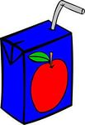
2. Ben likes __________. 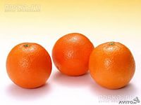
3. Do you like ___________ 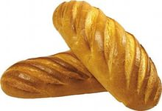 and _______ 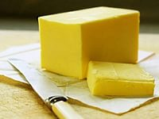 ?
4. My friends like ________ 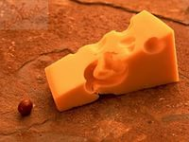

Phonetics. I - [ I ] kid, big

I – [ Ai ] kite, five

**Work with phonetics. P 61 ex 5 Which sound is different? Circle it.**

1. Kite, ice-cream, window.
2. Children, five, tide.

**Game . Simon says**

**Reading and writing, drawing. P 61 ex 4**

1. This is a monkey’s favourite food

.

|  |  |  |  |  |  |
| --- | --- | --- | --- | --- | --- |
| **B** |  |  |  |  |  |

1. Children like this fruit. It can be red, green, yellow.

|  |  |  |  |  |
| --- | --- | --- | --- | --- |
|  | **p** |  |  |  |

1. Cows give this. It is white. You drink it.

|  |  |  |  |
| --- | --- | --- | --- |
|  |  |  |  |

**Conclusion**. Put down the marks.

Home task. P 60 ex 1 to do the crossword